TASKS ON LOAD BALANCER
Title:
- Configure Classic Load balancer.
Objective :
To distribute incoming traffic across multiple backend servers using a Classic Load Balancer for improved availability, basic scalability, and fault tolerance.
Use Case :
Best for simple or legacy applications that need basic HTTP/HTTPS or TCP load balancing, health checks, SSL termination, or session stickiness without advanced routing.
Prerequisites (Short):
- VPC and Subnets available in at least two Availability Zones.
- EC2 instances launched and running in those subnets.
- Security groups allowing traffic from the load balancer to the instances.
- Health check endpoint configured on the backend instances.
- IAM permissions to create and manage load balancers.
- SSL certificate (only if configuring HTTPS/SSL).
Step by Step Implementation:
Step 1: Navigate to VPC and Create a VPC with 2 subnets in different Availability Zones
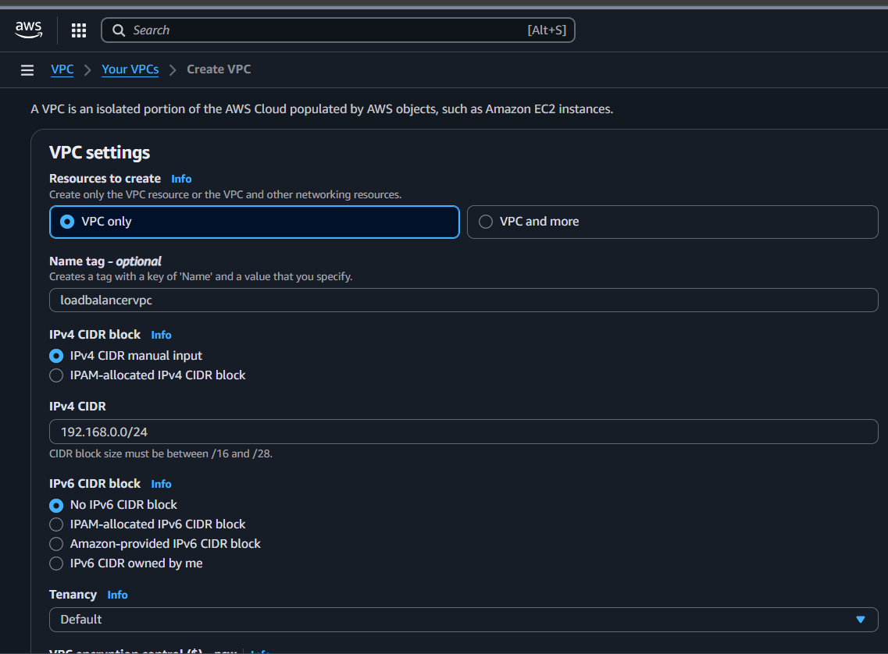
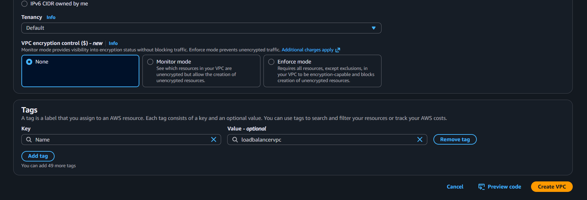
Successfully Created VPC
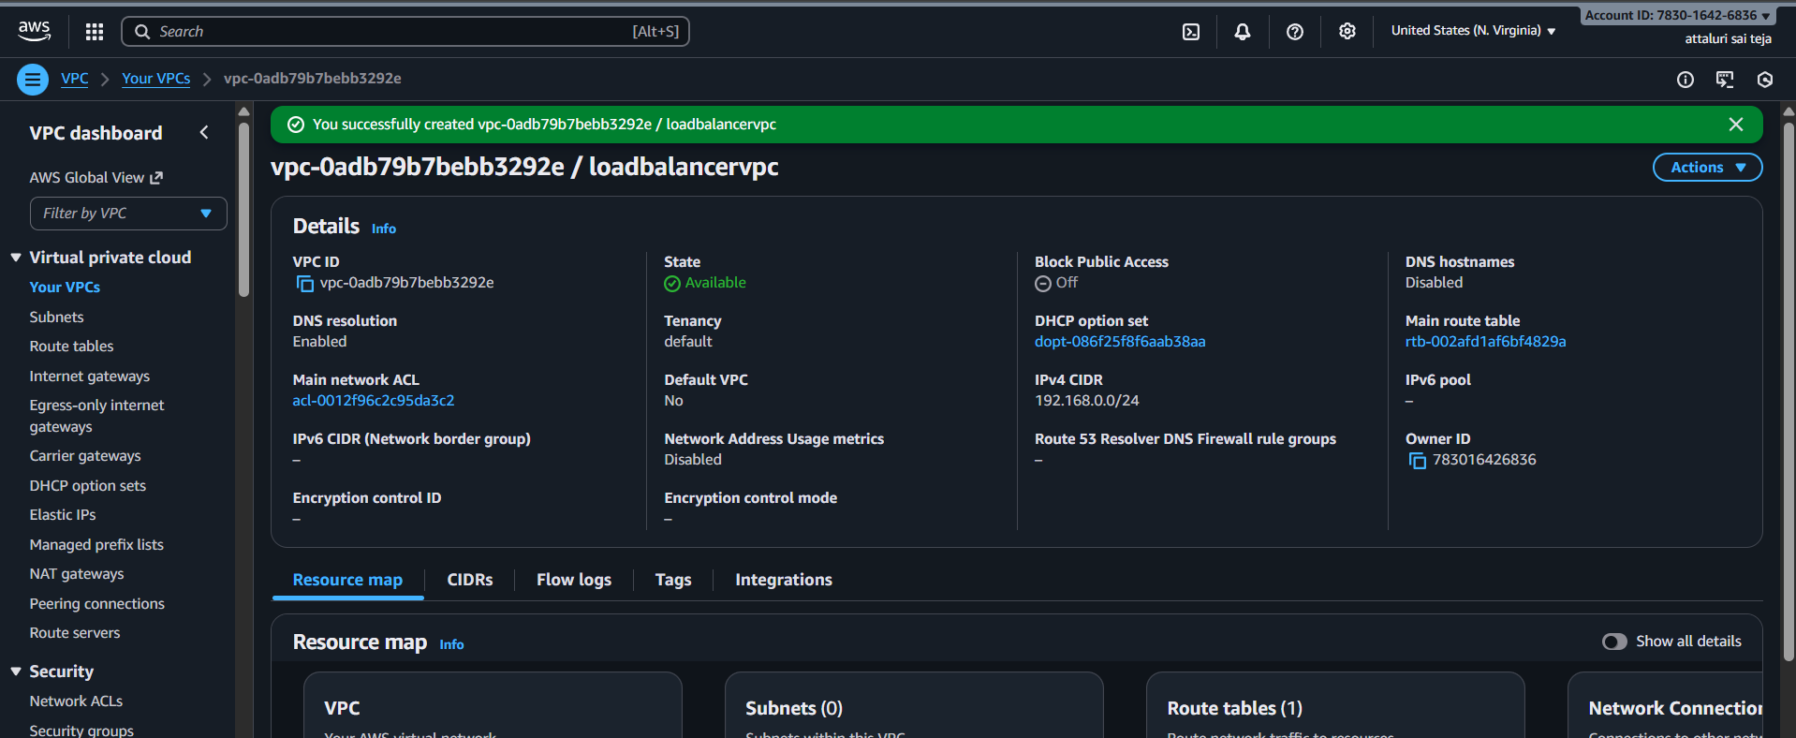
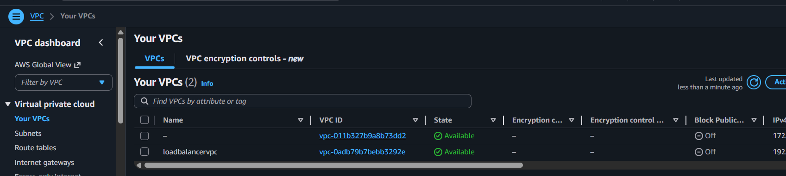

Step 2: Navigate to VPC and Select Subnet and create new two subnets in two different AZ
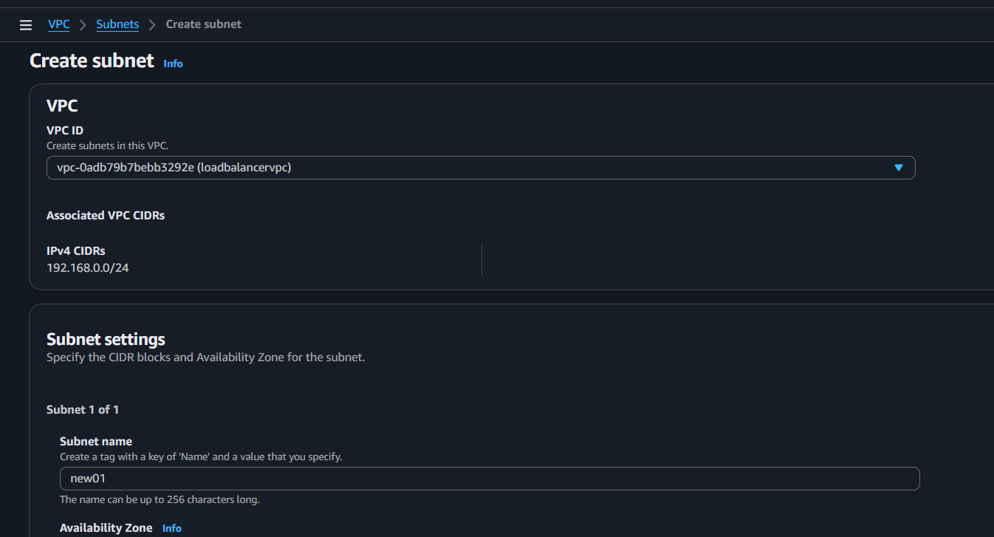
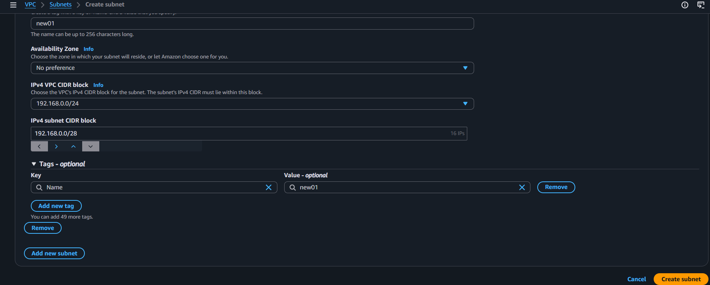
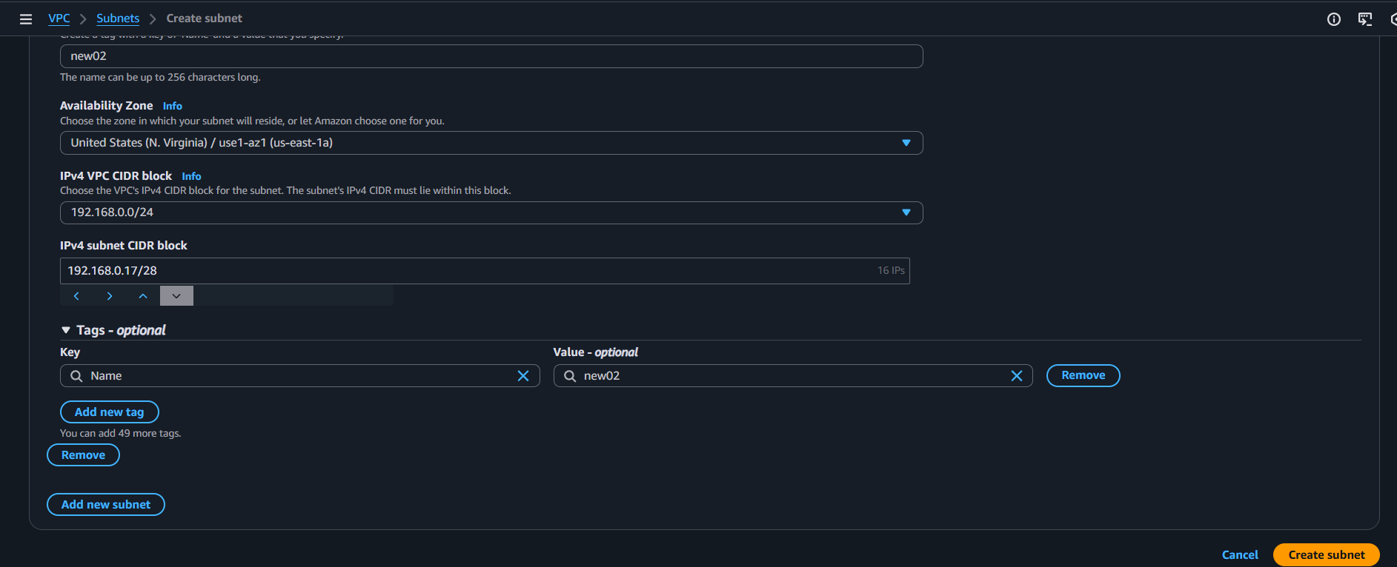
Successfully Created Two Subnets In two AZ
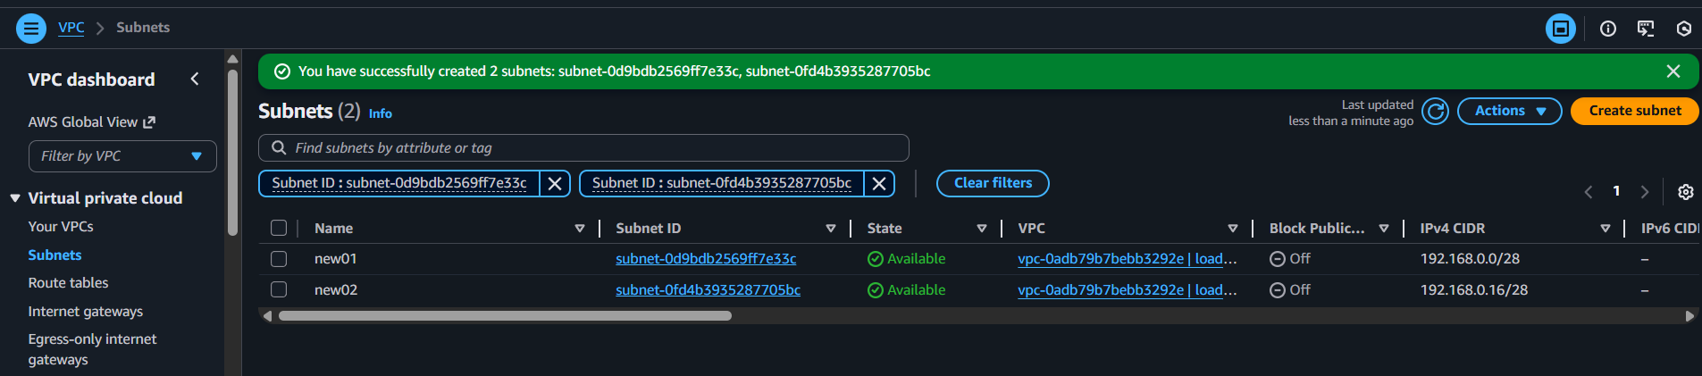
Step 3: Navigate to EC2 and launch two Instances from each Subnet
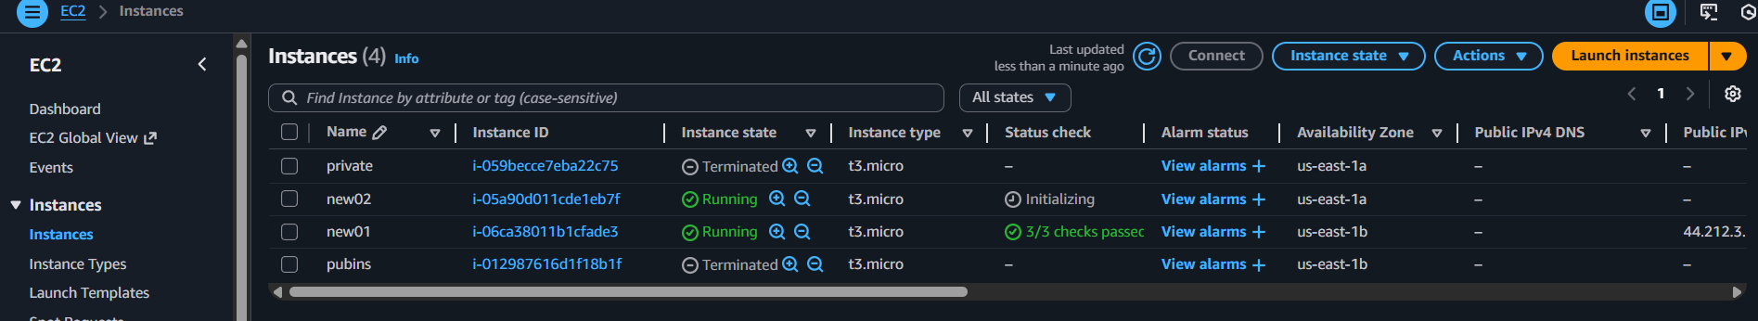
Step 4: Navigate to VPC and Create a IGW and attach it to VPC
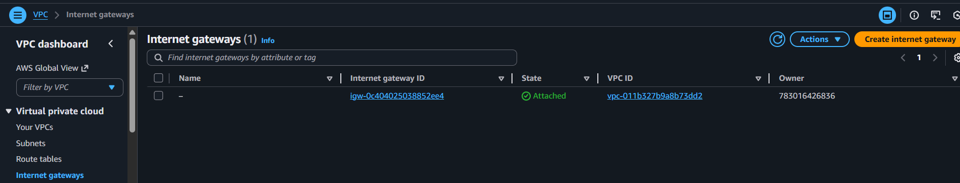
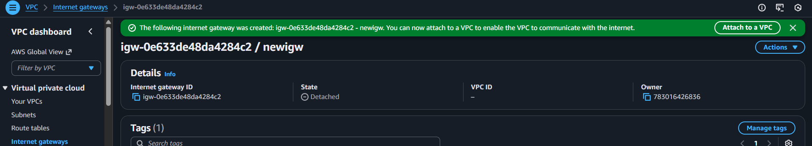
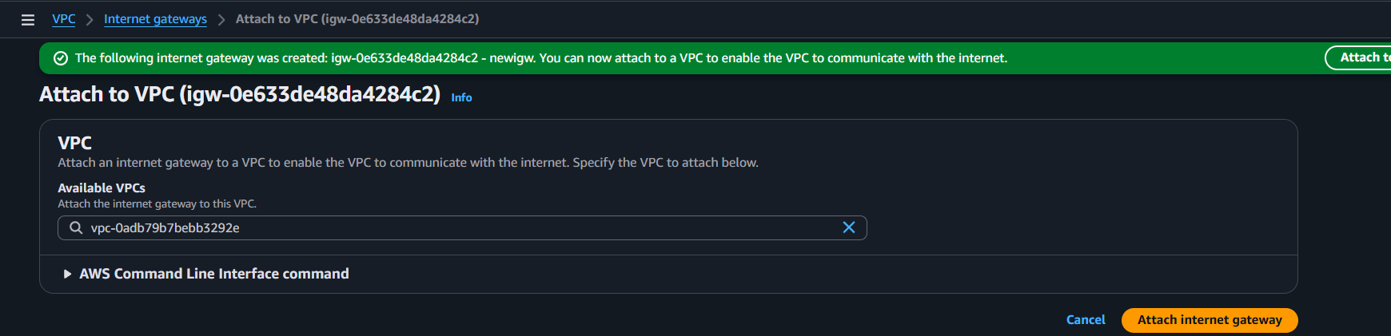

Step 5: Navigate to VPC and Select route tables and attach IGW to get internet access
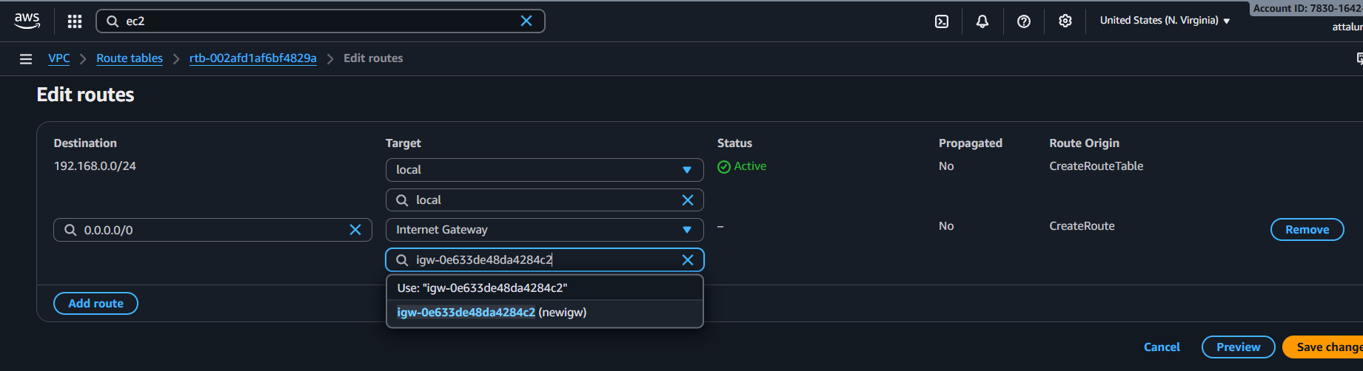
Step 6: Navigate to EC2 and edit Security groups and continue
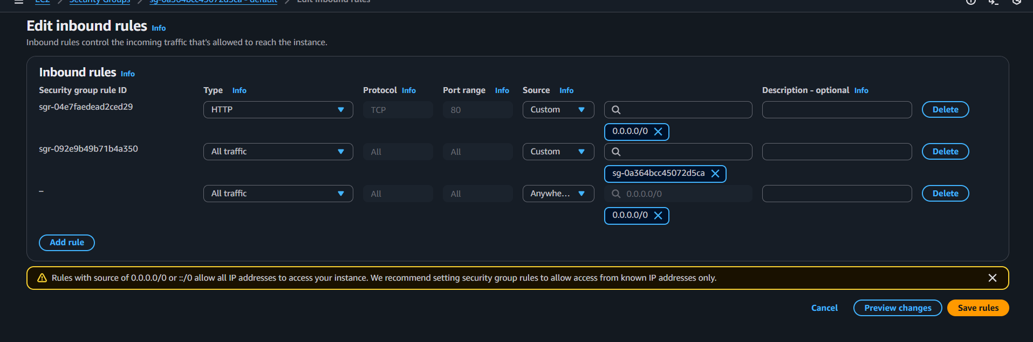
Step 7: Connect to EC2 instance and Install HTTPD package and start the service for both instances
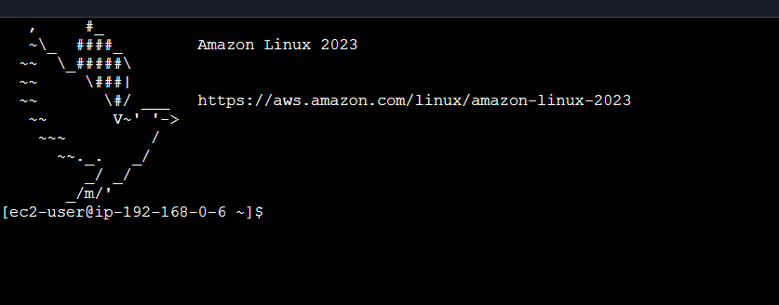
Step 8: Insert the data and continue to test in web browser using Publicip@portnumber
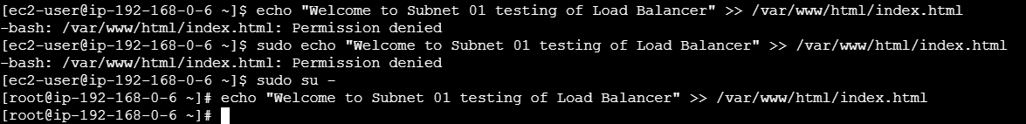

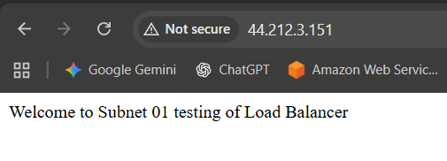
For 2nd Instance
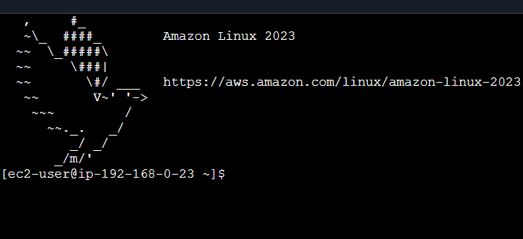
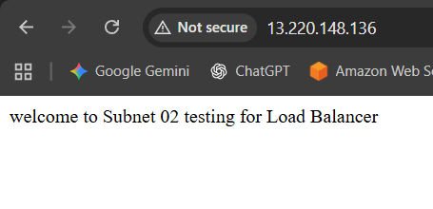

Step 9: Navigate to Ec2 and select Load balancers and click on create
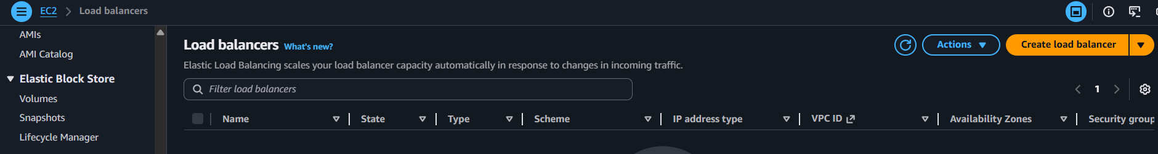
Click on classic load balancer and click on create
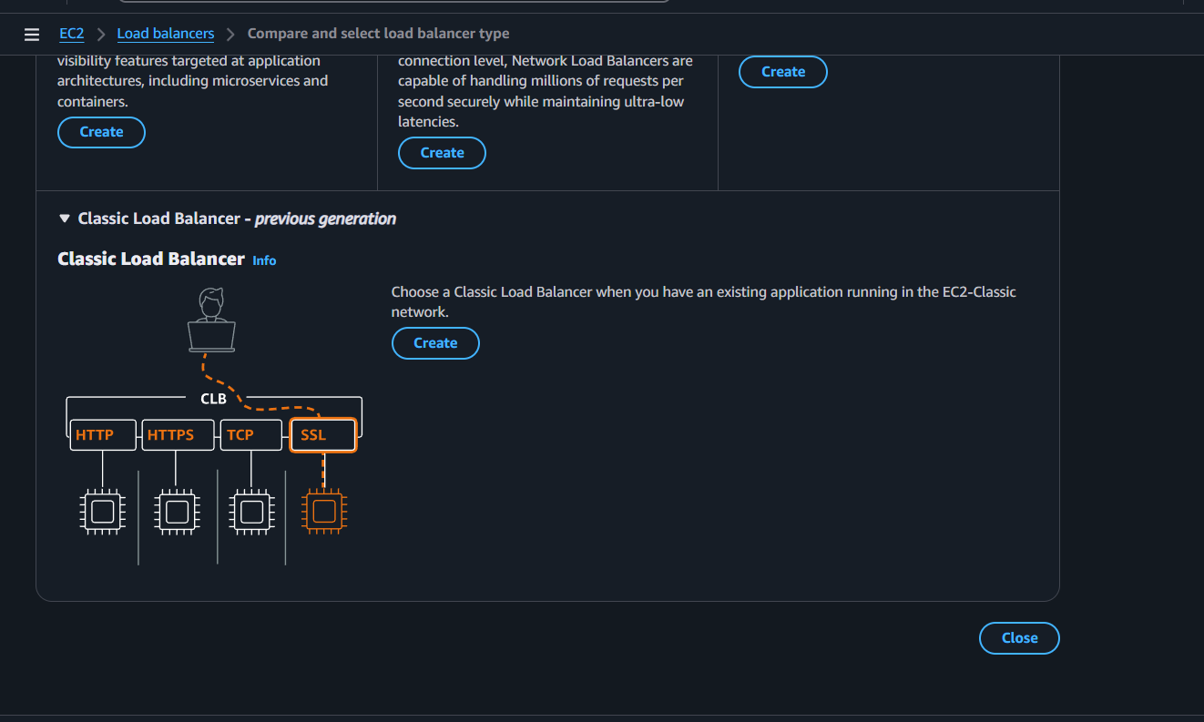
Provide a name to CLB and select VPC and continue
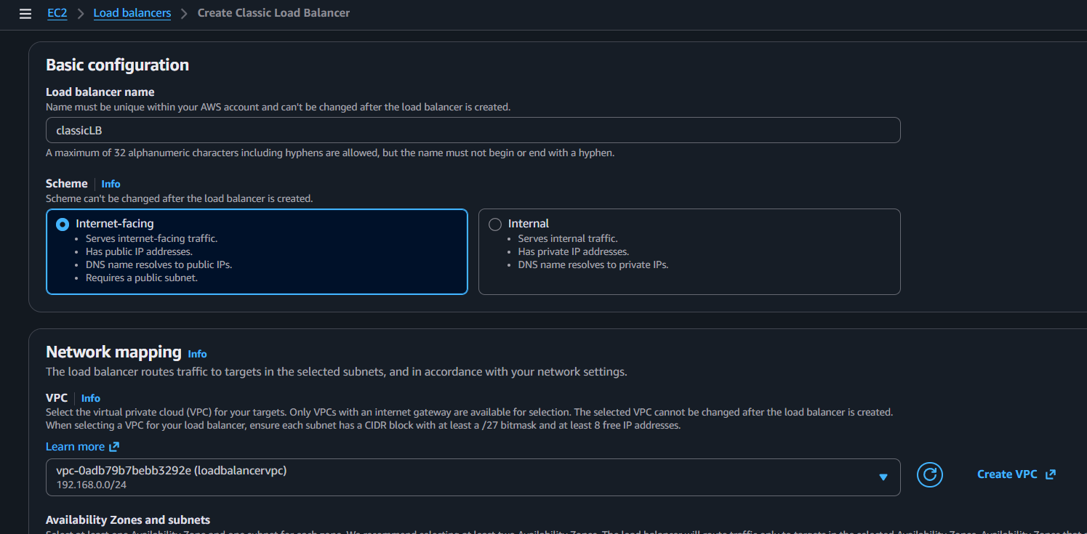

Select the subnets form different AZ
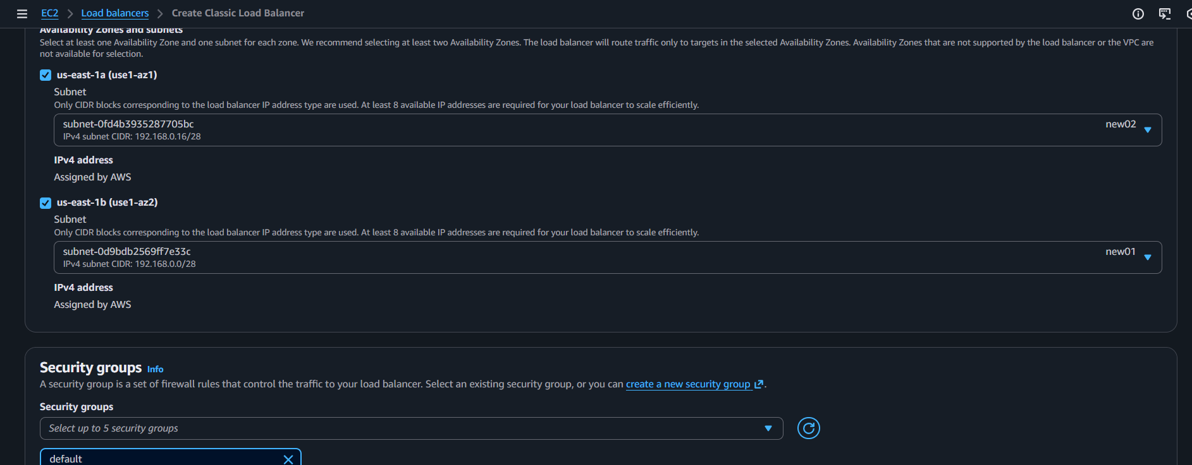
Update the Listeners according to your package and continue
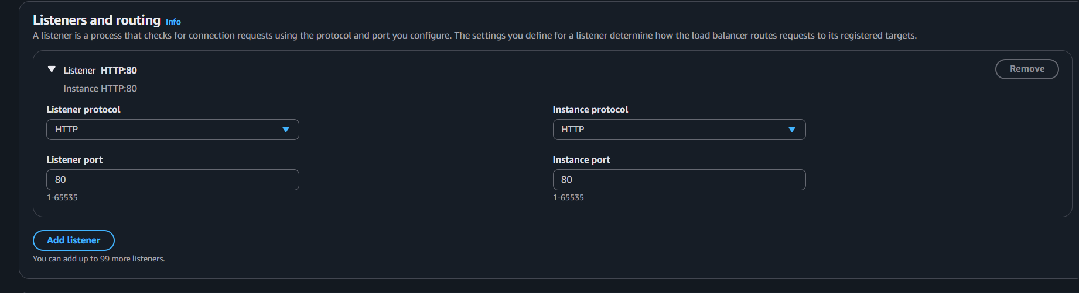
Select the health check path
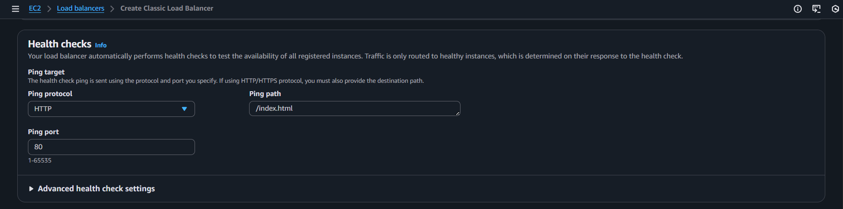
Select the Instances and continue for creating
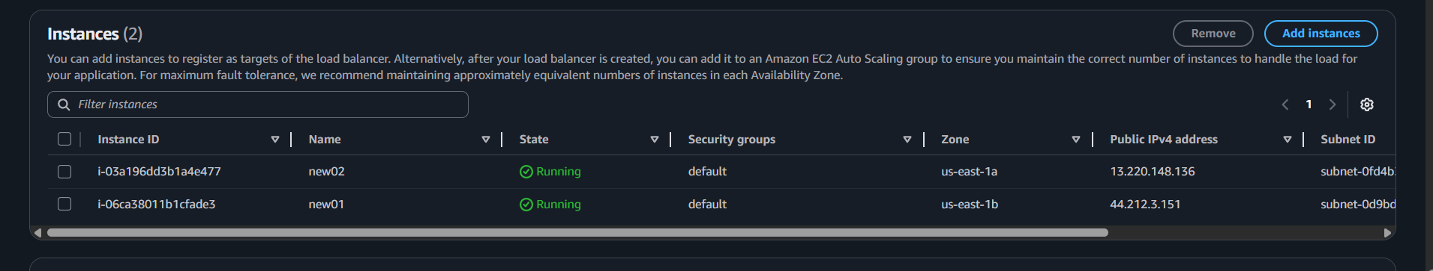

Select the attributes timing and proceed
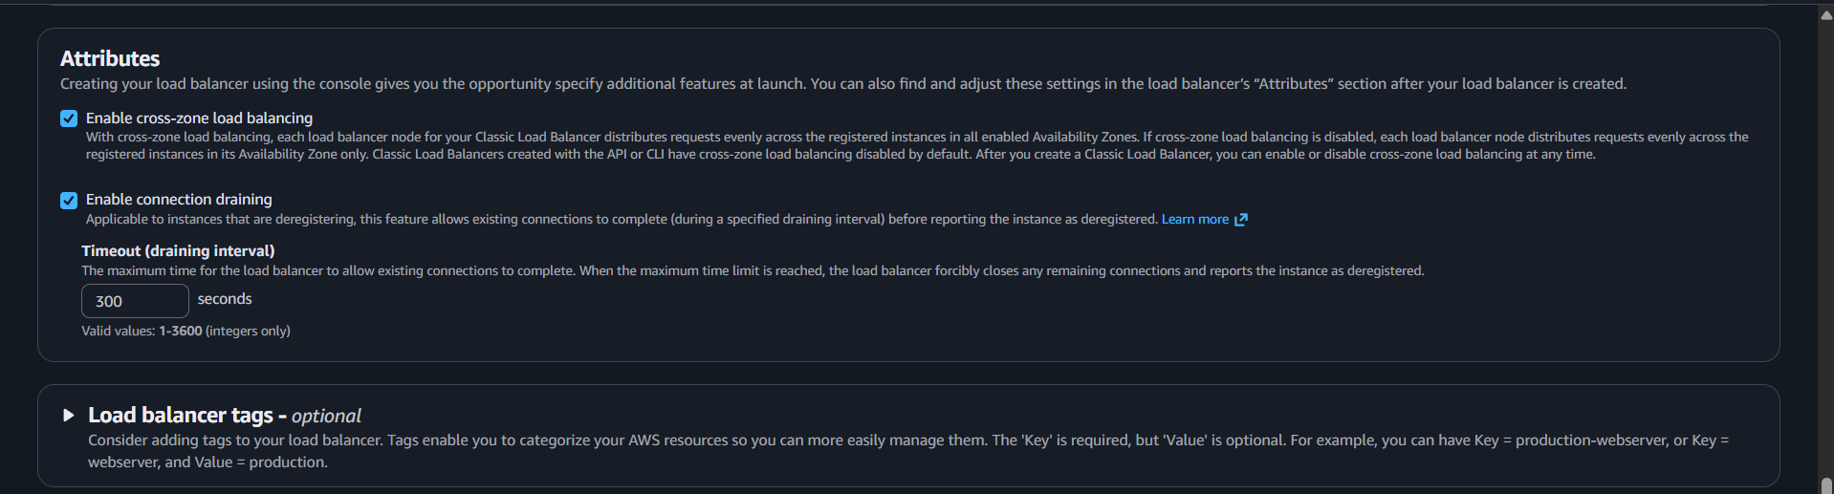
Review all the details and continue
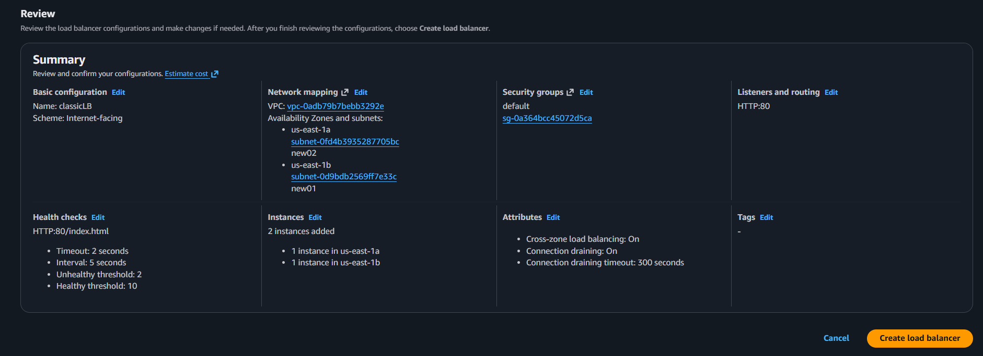
Load balancer has been created
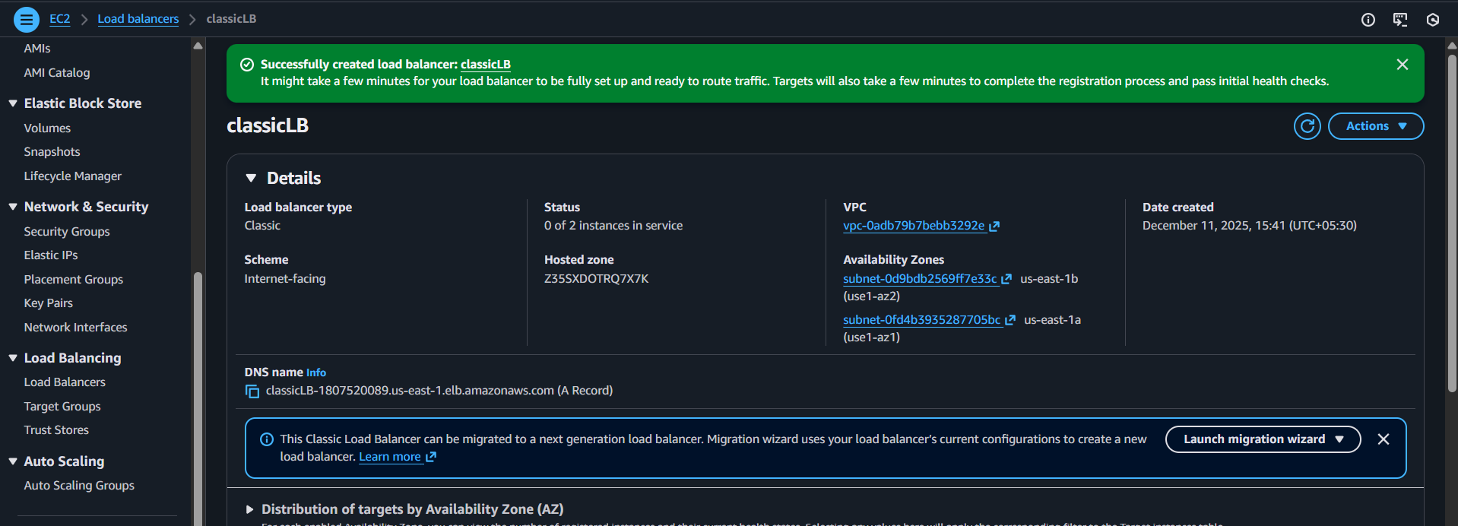

The site can’t be reached because of Health checks
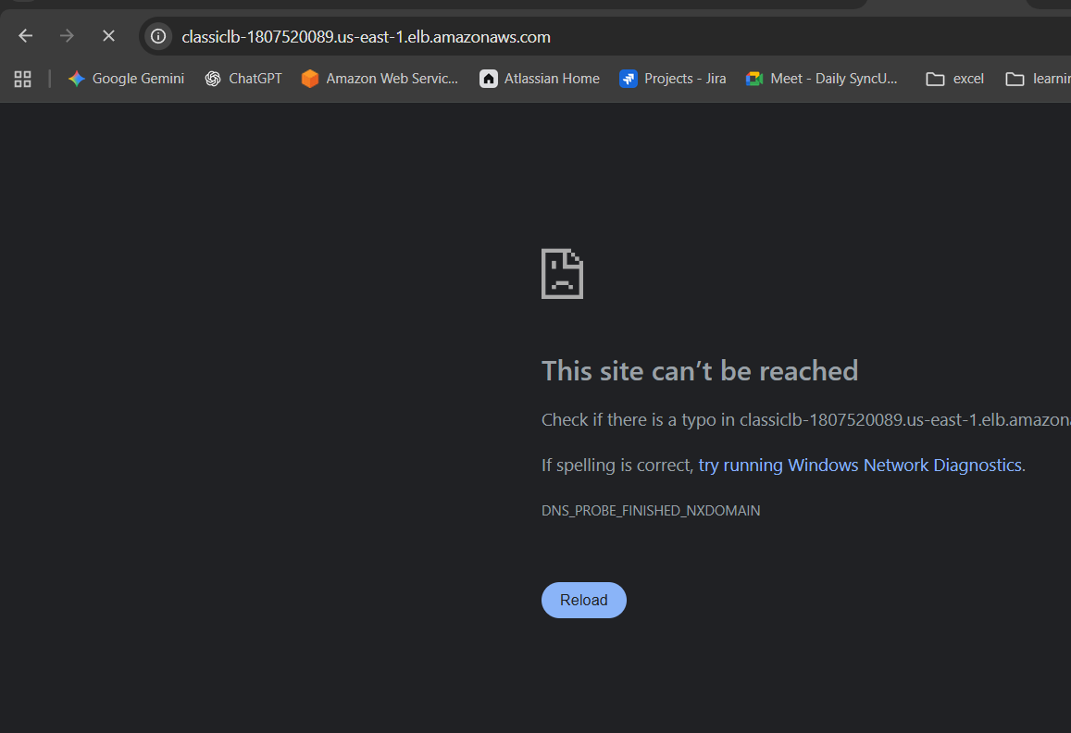
Wait for some time by that the health checks will be ok and continue
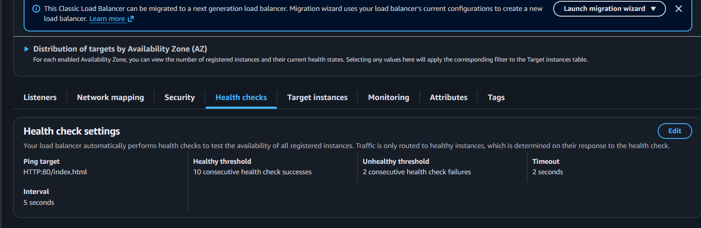
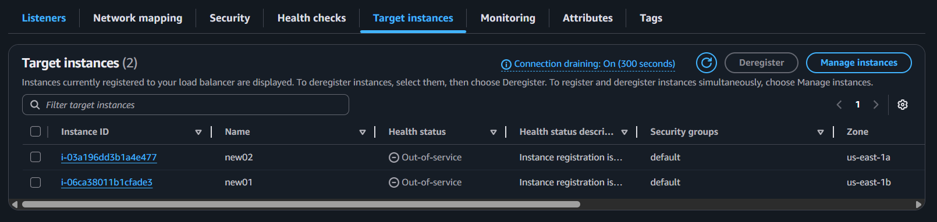
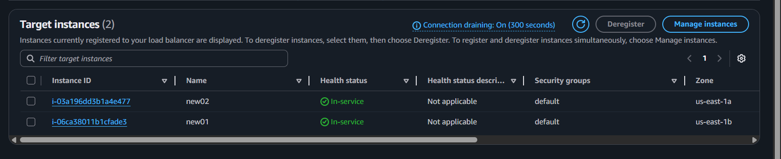
After Health checks again validated with link and verified



Conclusion (Short):
A Classic Load Balancer provides simple, reliable traffic distribution for older or straightforward workloads. It works well for legacy environments but is less advanced than modern ALB/NLB options.

Title:
- Configure Network Load balancer.
Objective
To distribute traffic at ultra-high performance and low latency using Layer-4 (TCP/UDP/TLS) load balancing, while handling millions of requests per second with high availability.
Prerequisites
- VPC and subnets in at least two Availability Zones.
- EC2 instances / targets running with the required application ports open.
- Target group created for TCP/UDP/TLS traffic.
- Security groups on instances allowing inbound traffic from the NLB (NLB itself has no SG).
- Elastic IPs (optional) if you want static IP addresses for the NLB.
- Health check endpoint configured for TCP/HTTP/HTTPS health checks.
Step by Step Implementation:
Step 1: Navigate to EC2 and select Load balancer and click on create load balancer
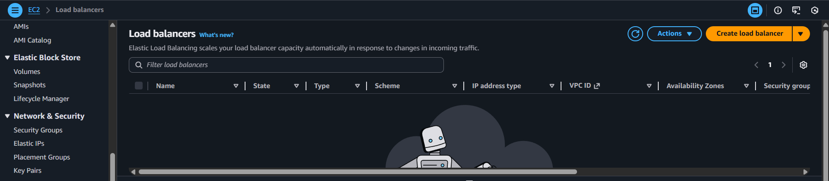
Click on the type which you need to create
I selected NETWORK LOAD BALANCER
Use Cases:
- High-performance TCP apps – real-time trading systems needing ultra-low latency.
- UDP-based services – gaming or VoIP servers.
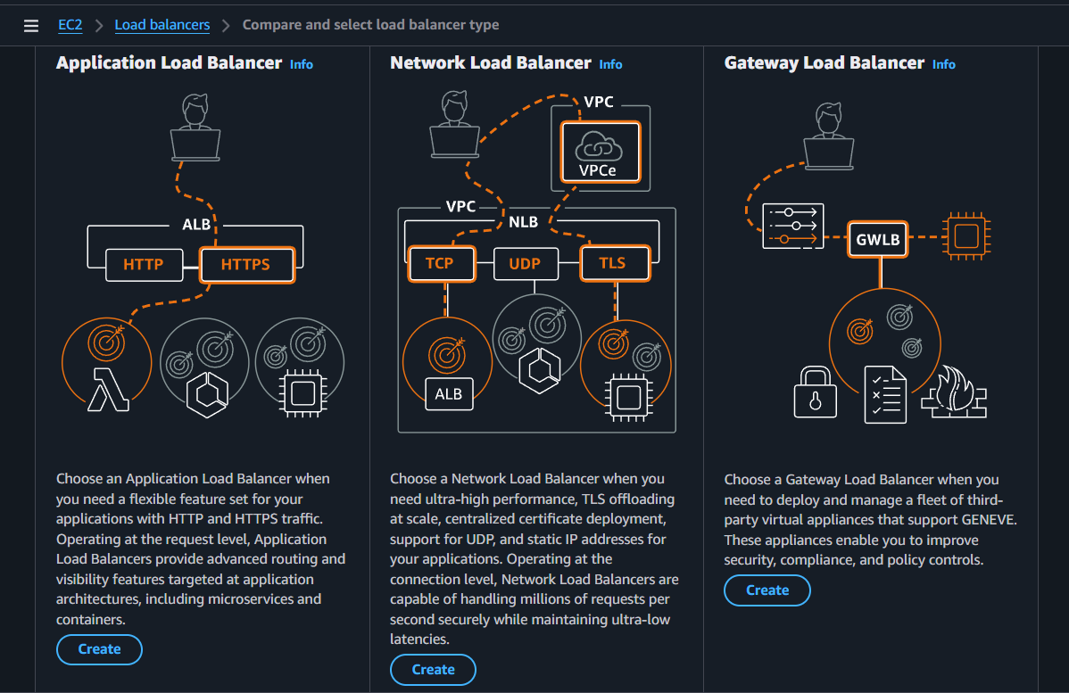
Provide the name and select the scheme type and continue
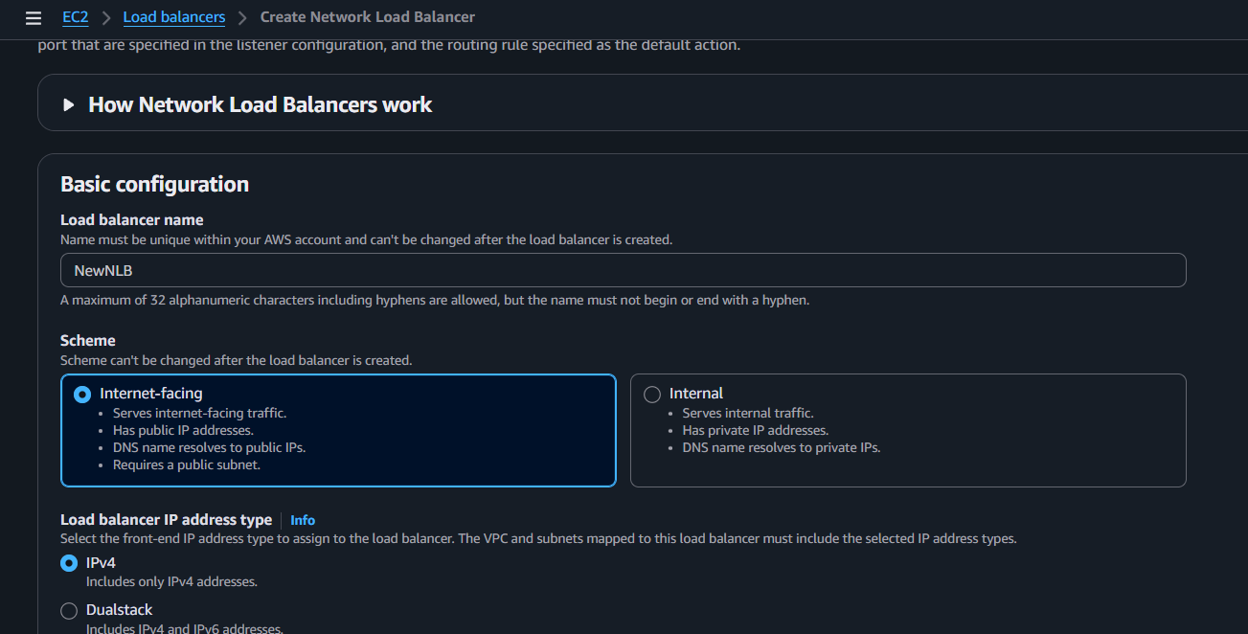

Select the VPC and Select Subnets and continue
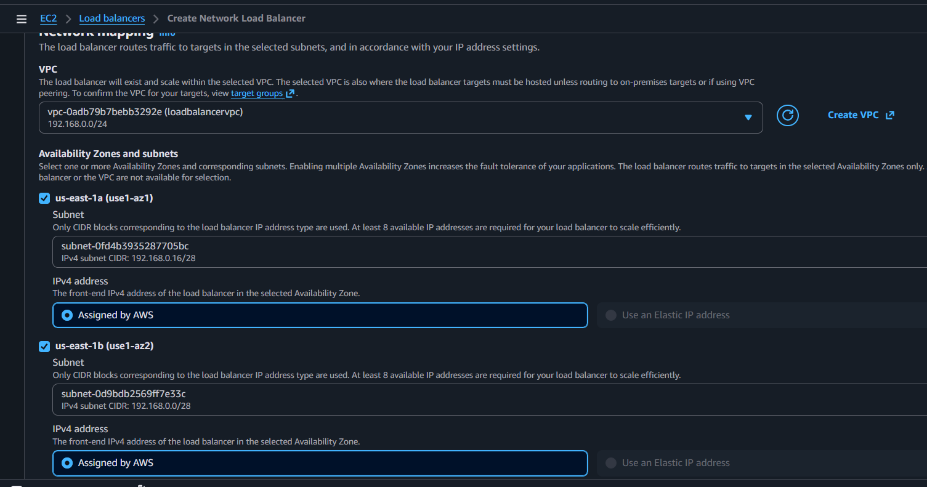
Select security groups as well
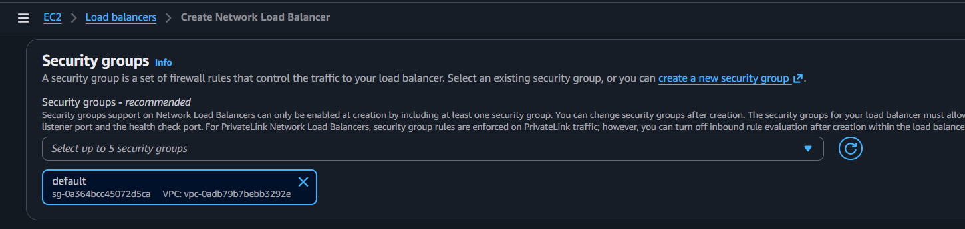
We need to create a TARGET GROUP
Here is the process >>> Click on the Create target group and continue
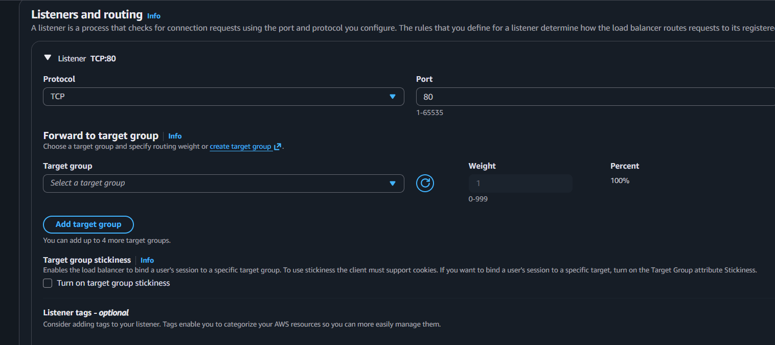
Select the Target type and continue
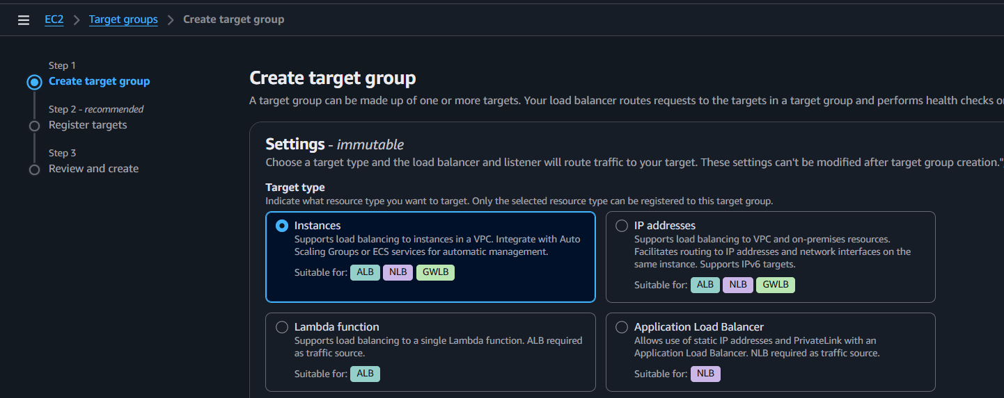
Provide a name and continue by verifying port number and protocol
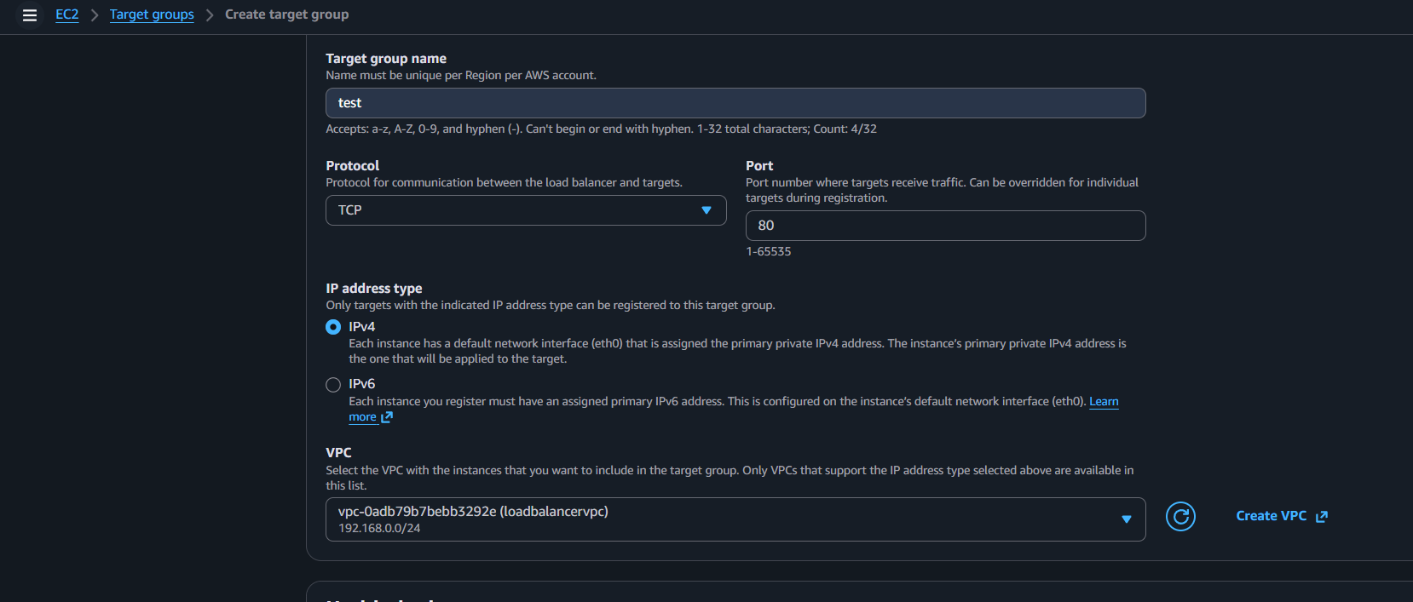
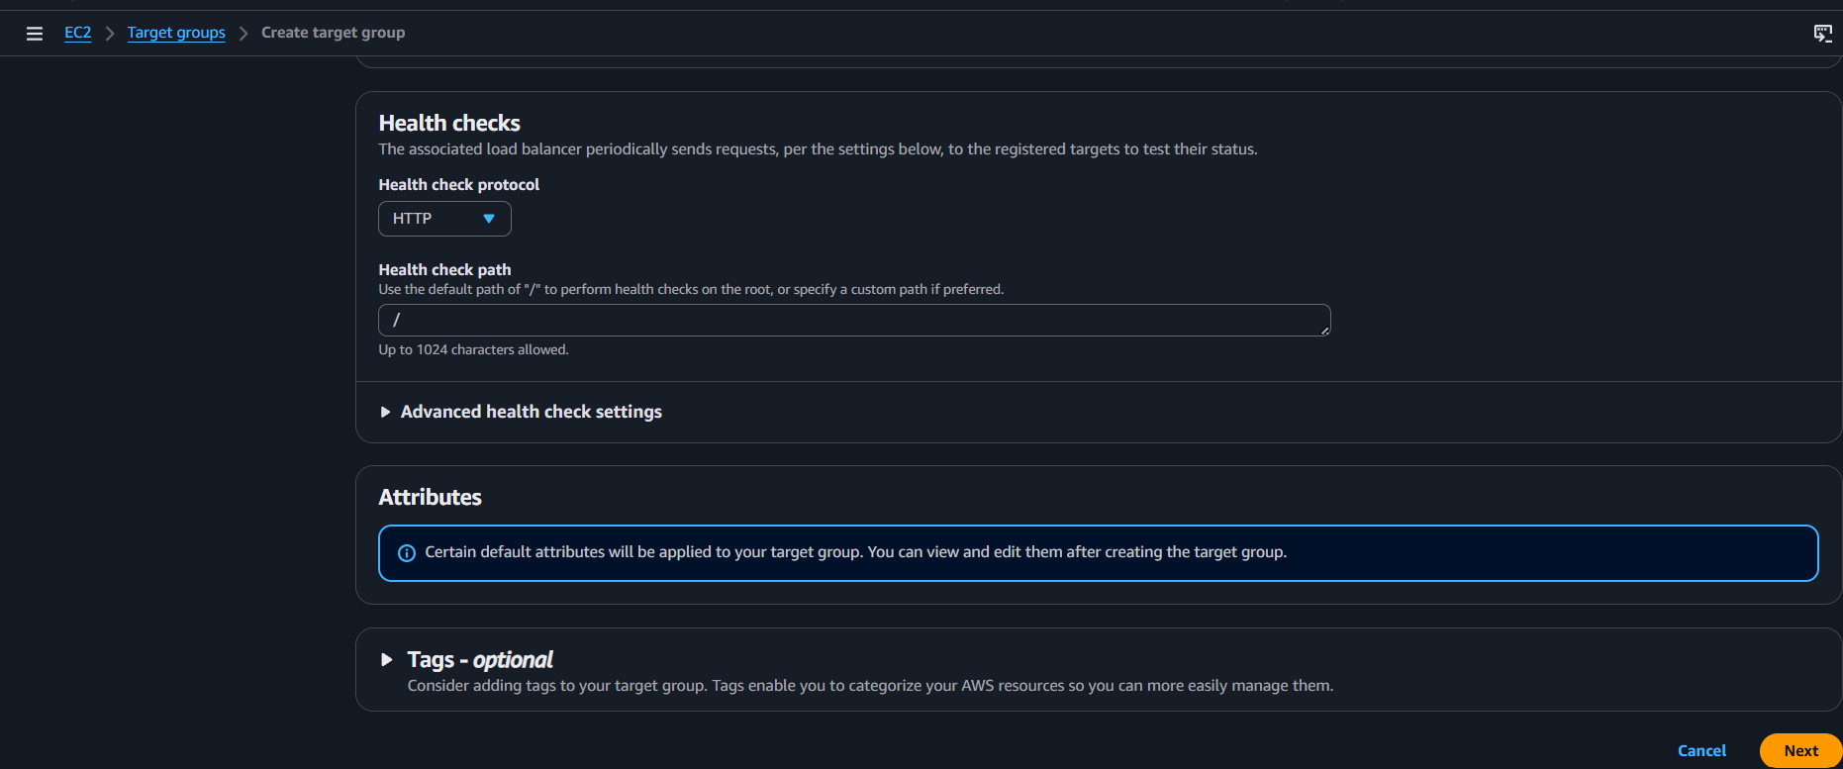

Select the instances and add to target group
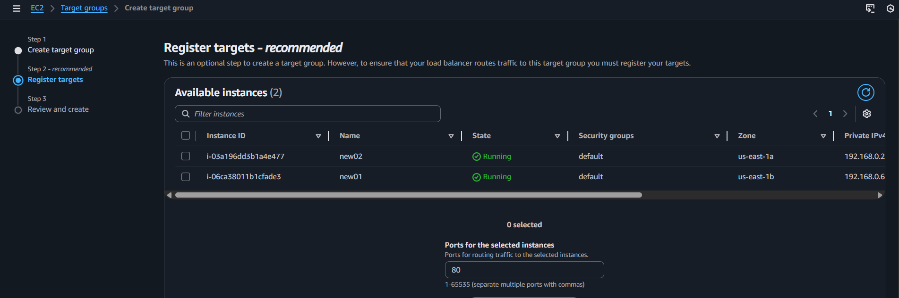
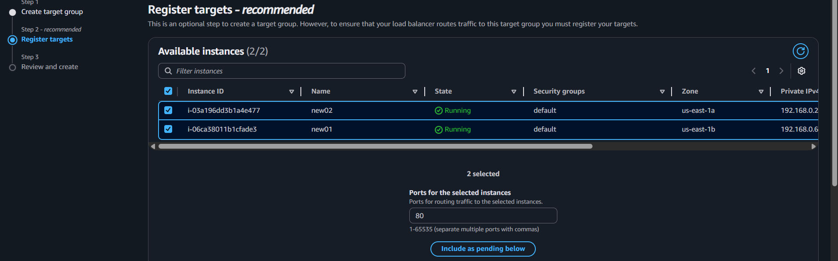
After all click on next and review the details and proceed for creation of TARGET Groups
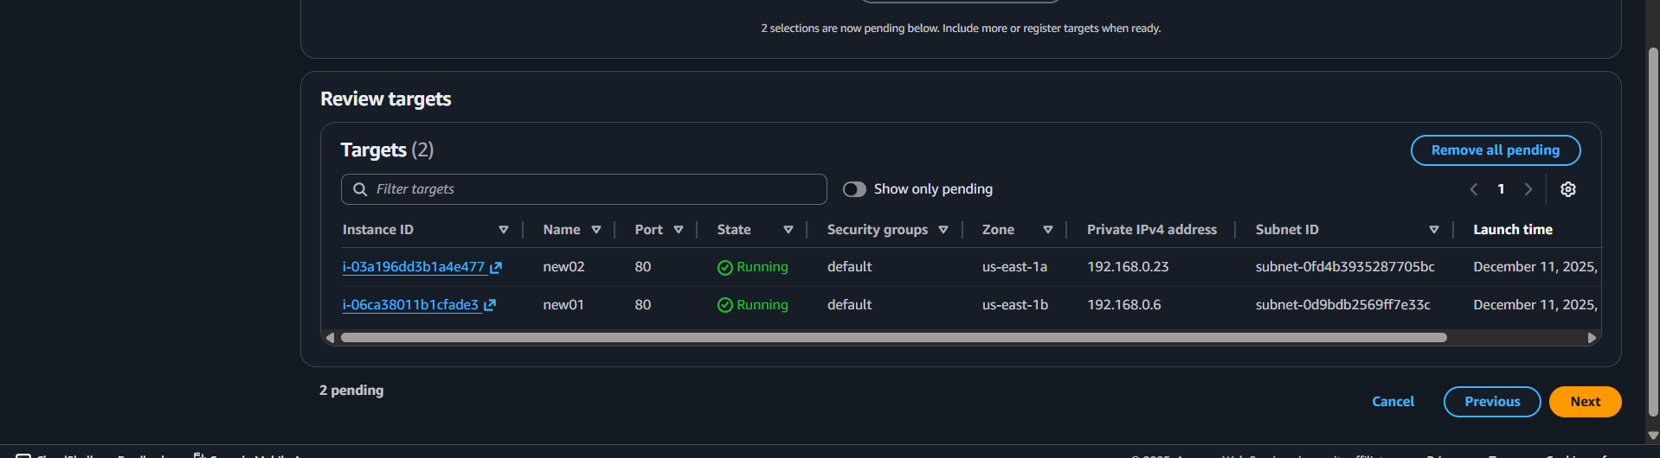
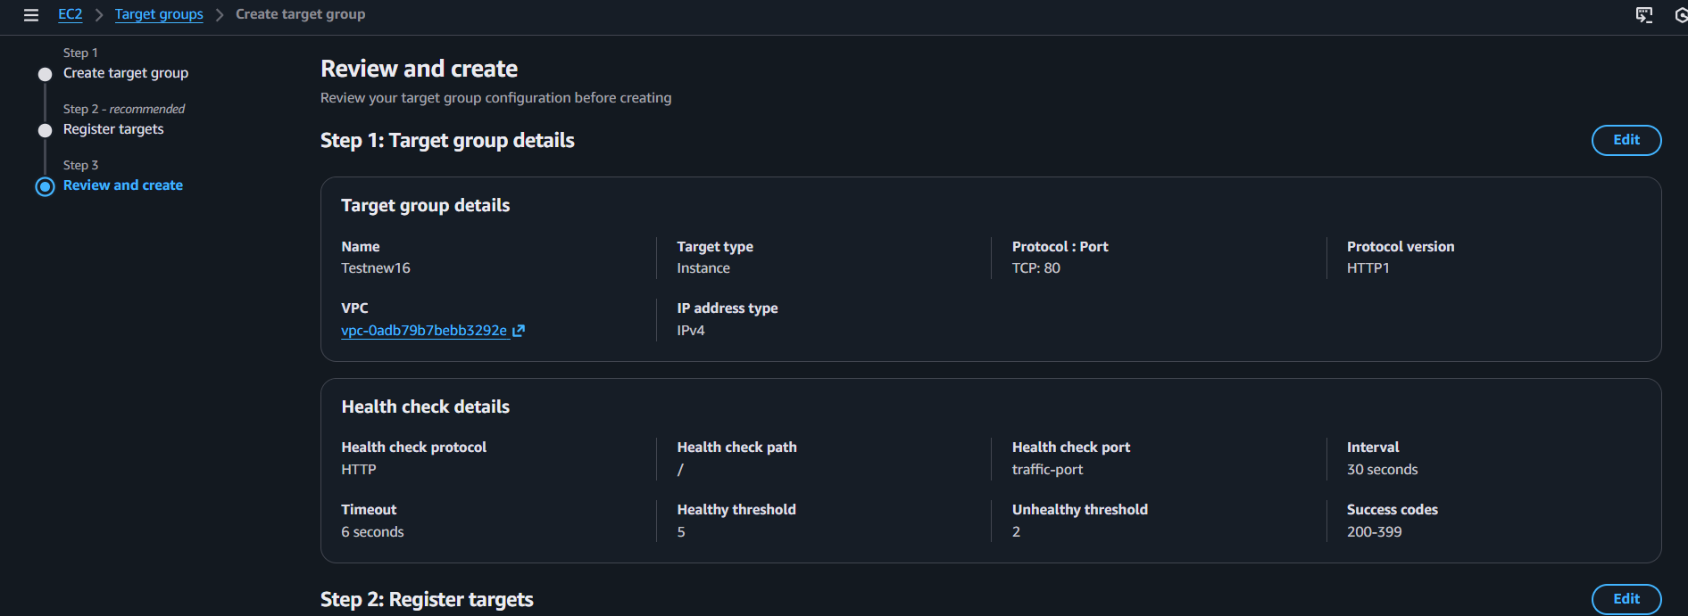
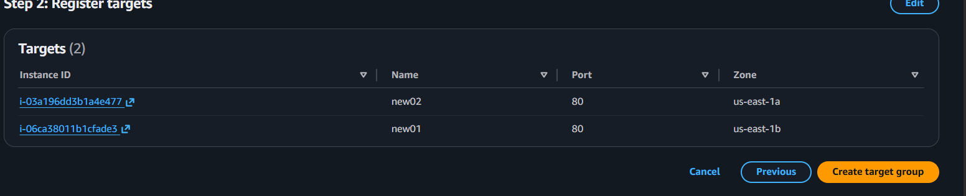
That’s the target groups were created and lets check health of each instance
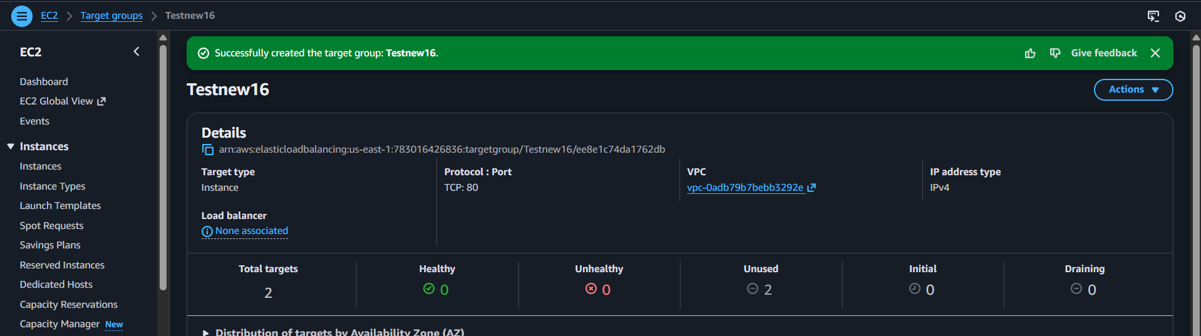
The output is like the health checks were unused and lets move to used state by creating load balancer
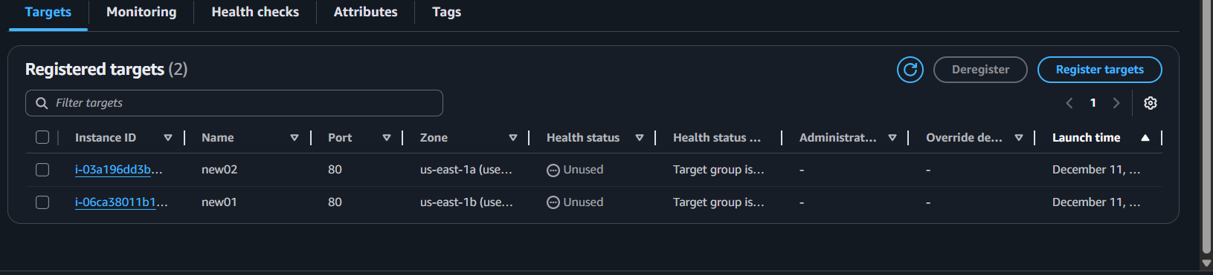
Navigate back to Load balancer and select the target group and continue
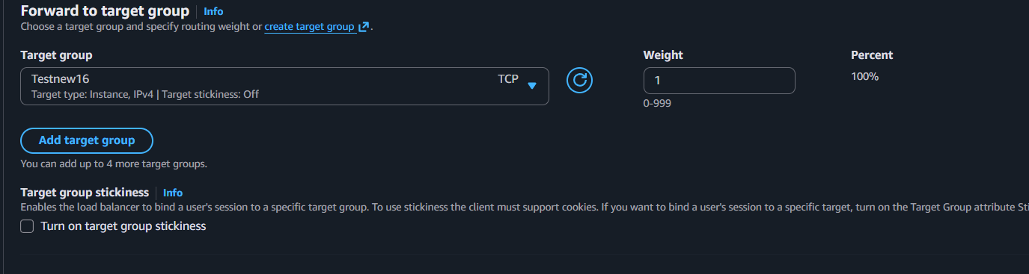

Successfully created Network load balancer
With the DNS name Link will verify the Application in WEB browser
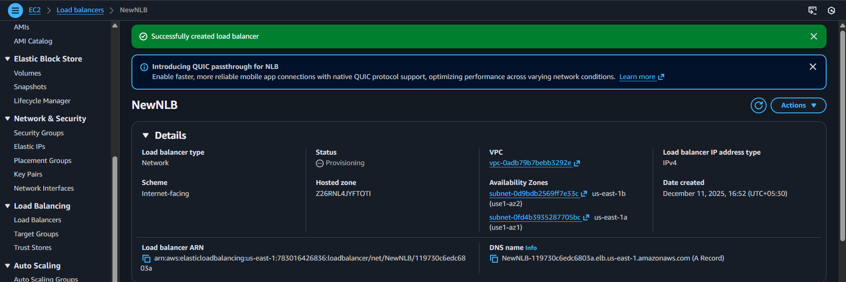
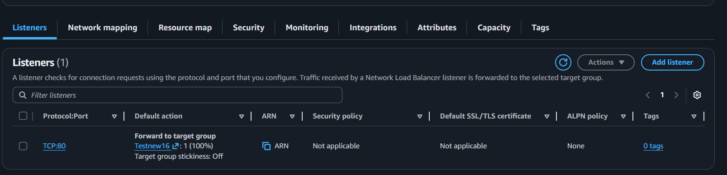
The Instances were in initial stage wait for some time and all will be available
Before in initial stage I performed verification in web browser and I got null response
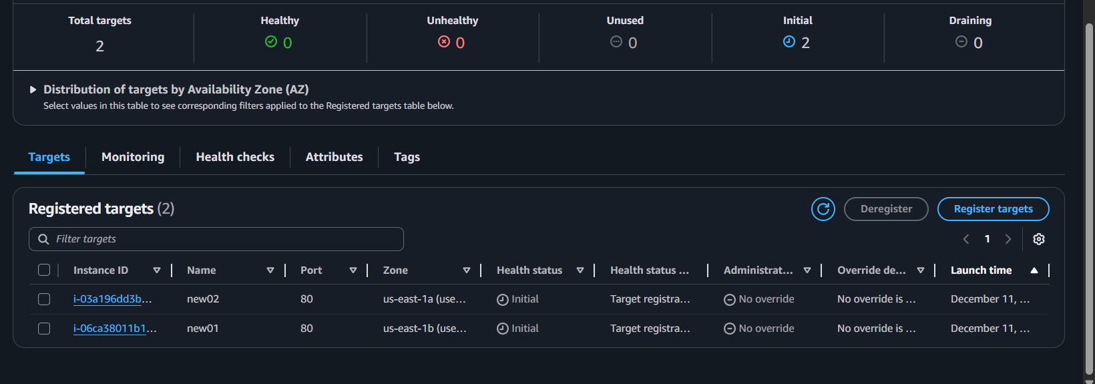
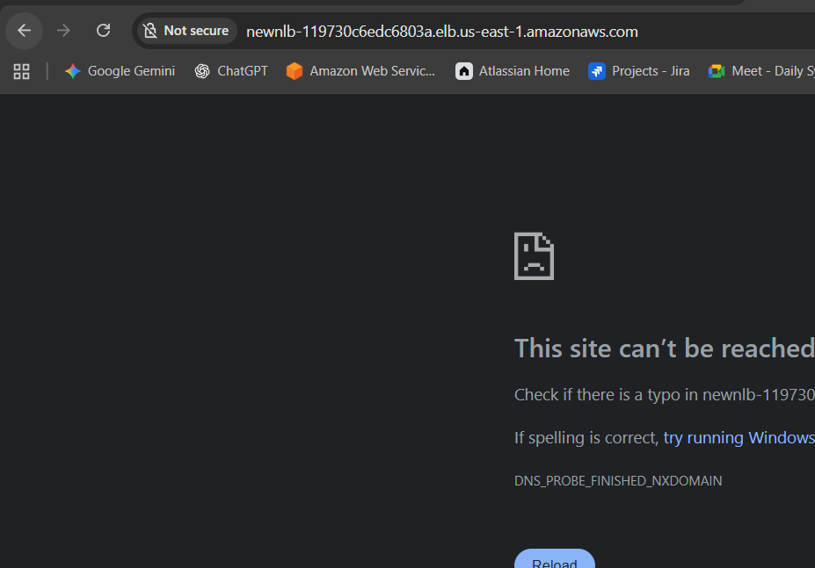
After the Status get Healthy then try once again by that the application could be accessed
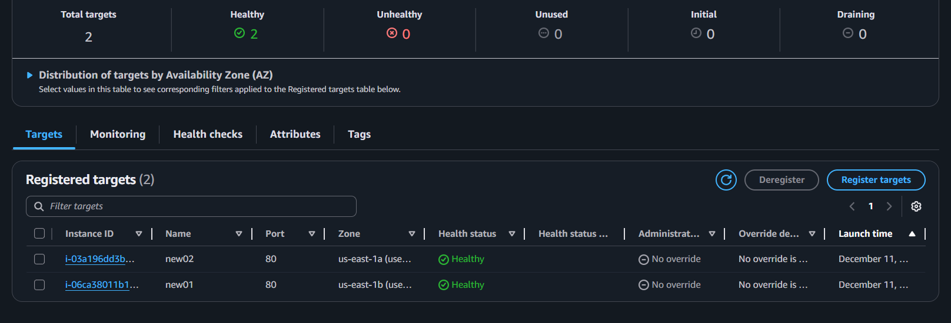
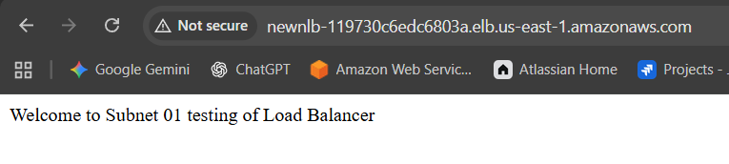


Issues Faced:
There was a lag in getting application connecting to another, after some time able to test application in both instances
Conclusion:
A Network Load Balancer is ideal when you need extreme performance, static IPs, and support for TCP/UDP/TLS traffic. It offers superior speed and scalability compared to Classic or Application LBs, making it the best choice for real-time, latency-sensitive, or high-volume workloads.
Ex: For streaming applications

Title:
- Configure Application Load balancer.
Objective:
To distribute incoming HTTP/HTTPS (Layer-7) traffic intelligently across backend targets using advanced routing features such as path-based, host-based, and header-based routing, improving scalability, flexibility, and application performance.
Use Cases
- When you need advanced routing (URL path, hostname, headers, query strings).
- Modern web apps / microservices that require routing to multiple services behind one LB.
- Content-based routing for APIs, web apps, or multi-tenant platforms.
- WebSockets and HTTP/2 application support.
- Centralized SSL/TLS termination for multiple services.
Prerequisites :
- VPC with subnets across at least two Availability Zones.
- Security groups allowing inbound traffic (HTTP/HTTPS) to ALB.
- EC2 instances / containers running your app.
- Target groups created for HTTP/HTTPS routing.
- Health check endpoint available (e.g., /health).
- SSL certificate if using HTTPS (ACM recommended).
- IAM permissions to manage ALB and target groups.
Step by Step Implementation:
Step 1: Navigate to EC2 and Select Load balancers and click on create
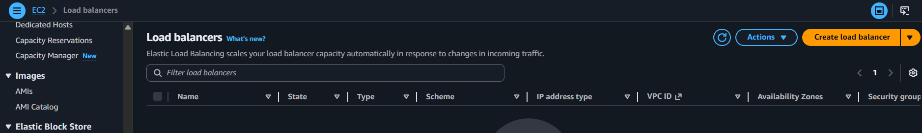

Follow the same steps for creating application load balancer same as CLB and NLB
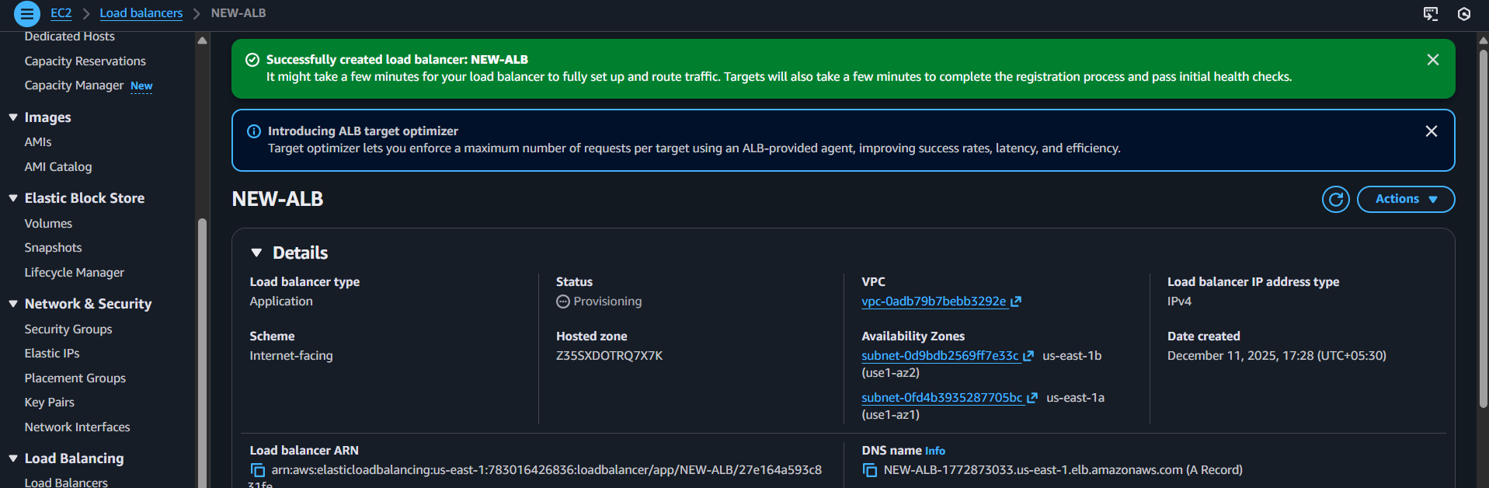
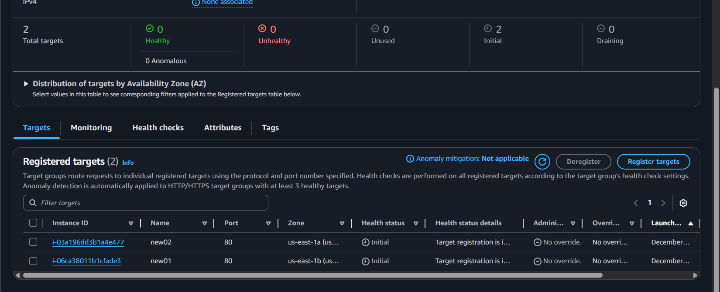
After Successful Health Checks we can can verify our application in website
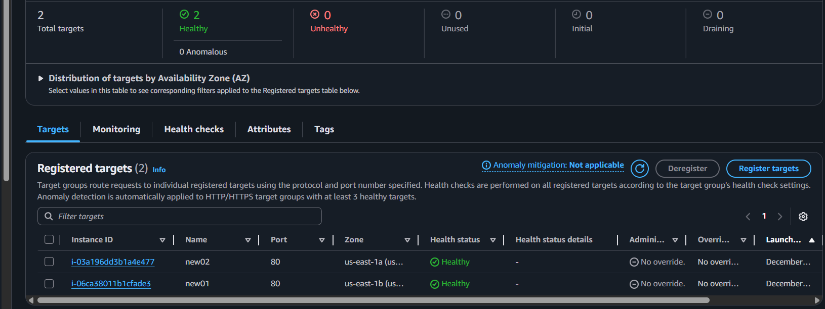
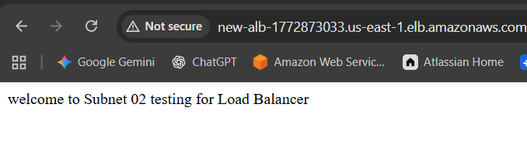
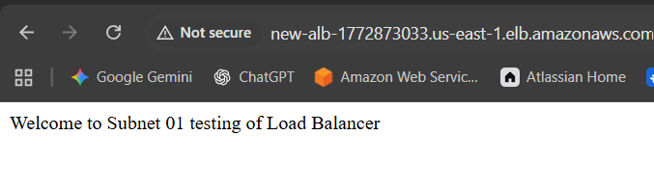
Conclusion:
Application Load Balancer is ideal for modern web services that require smart Layer-7 routing, high flexibility, and support for HTTP/HTTPS, WebSockets, and microservices. It provides more features than Classic Load Balancer and is the recommended choice for web apps, APIs, and microservices architectures.

Title:
- Attach SSL for application load balancer.
- Map Application load balancer to R53.
Objective:
To enable secure HTTPS communication by attaching an SSL/TLS certificate to the ALB so that all incoming traffic is encrypted and securely terminated at the load balancer.
Use Cases:
- Protecting websites, APIs, and applications with HTTPS.
- Enforcing secure user login and data confidentiality.
- Offloading SSL processing from backend servers (improves performance).
- Meeting security compliance requirements such as PCI-DSS or HIPAA.
- Serving multiple secure domains using SNI (Server Name Indication).
Prerequisites
- Application Load Balancer already created.
- SSL Certificate issued from ACM or uploaded manually.
- Domain ownership verification (for ACM certificates).
- HTTPS Listener (port 443) configured on ALB.
- Security group allowing port 443 inbound.
- Correct target group for forwarding decrypted traffic.
Step by Step Implementation:
Step 1: ALB is already created
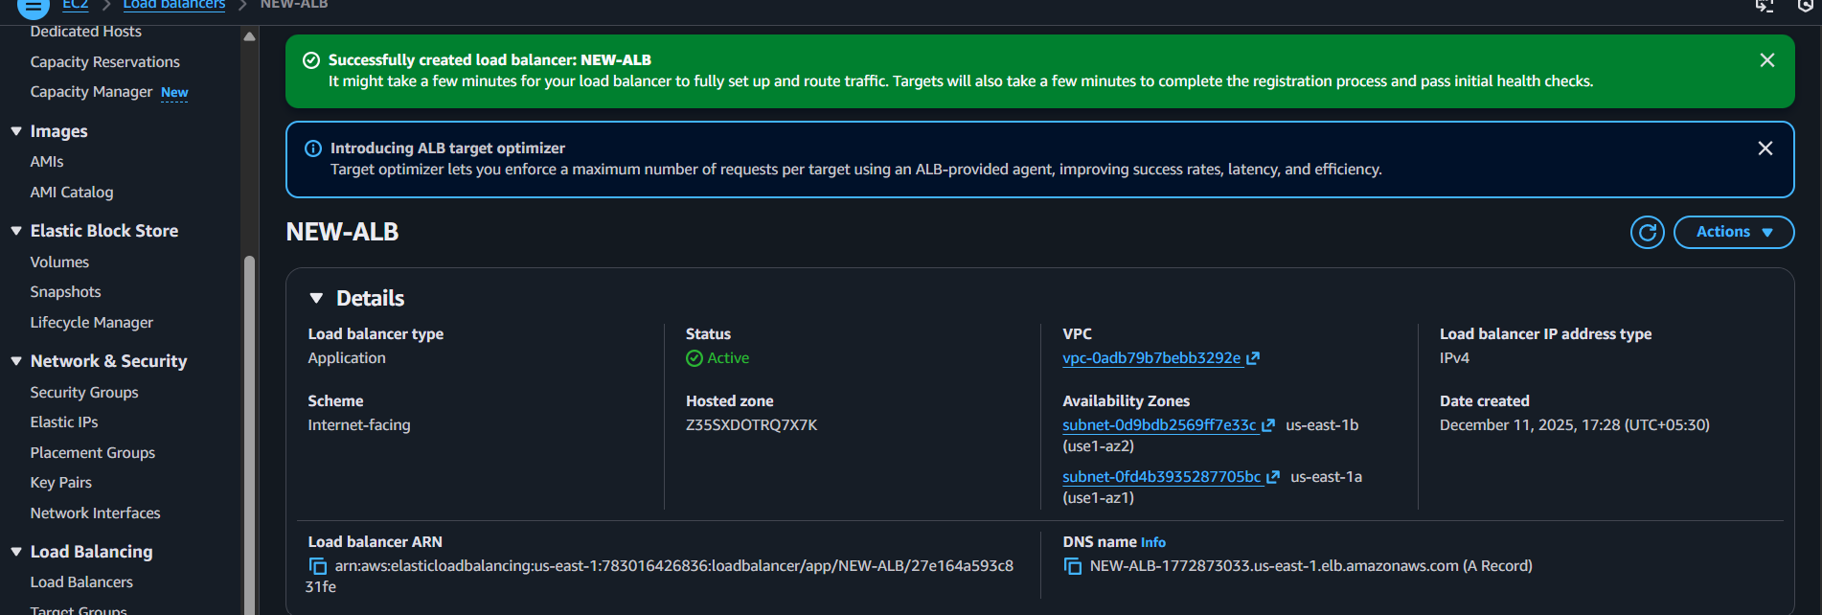

Navigate to Domain and copy the domain name
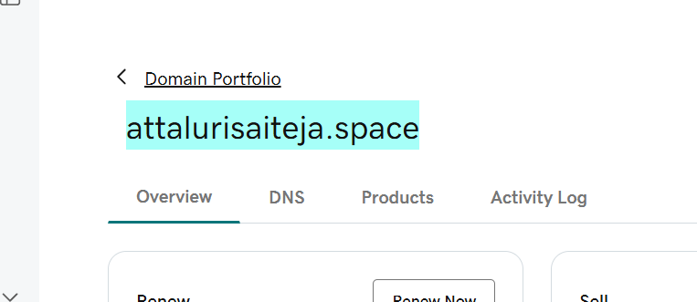
Step 2: Navigate to ROUTE 53 and create a hosted zone
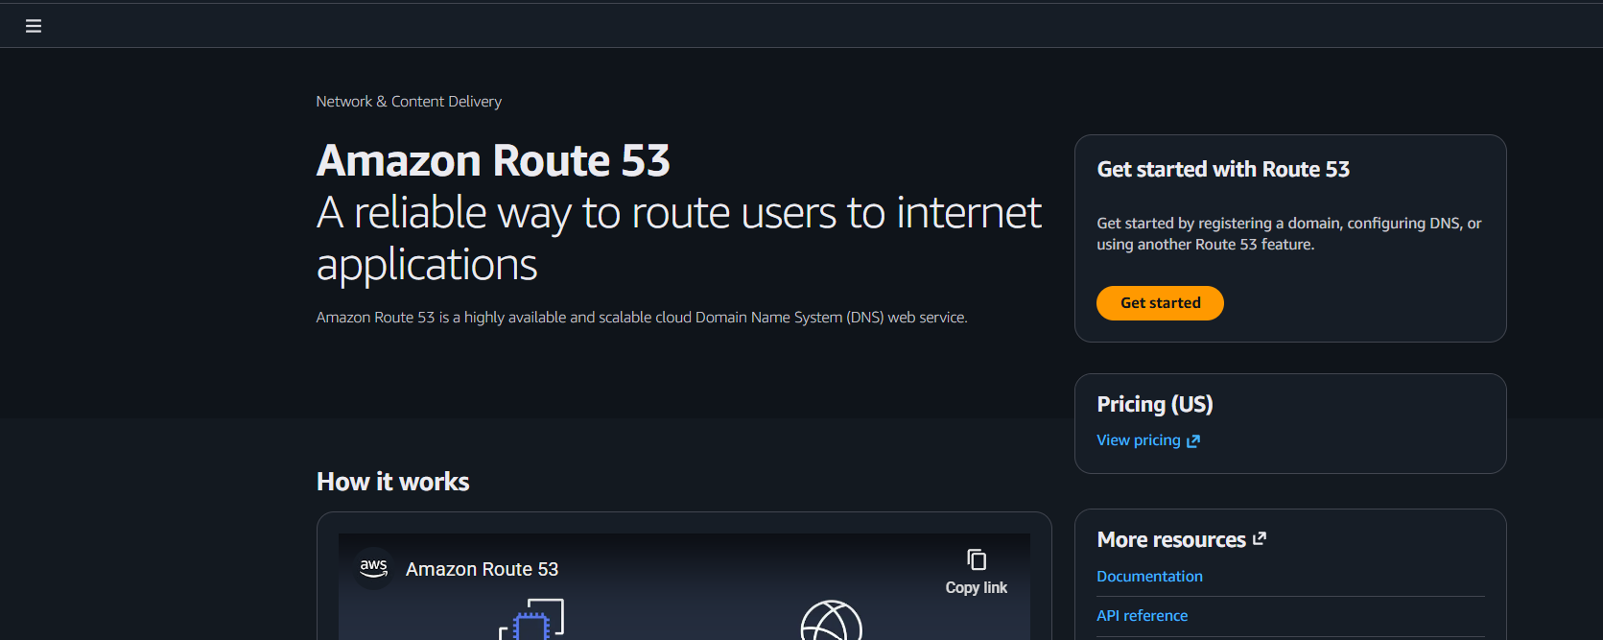
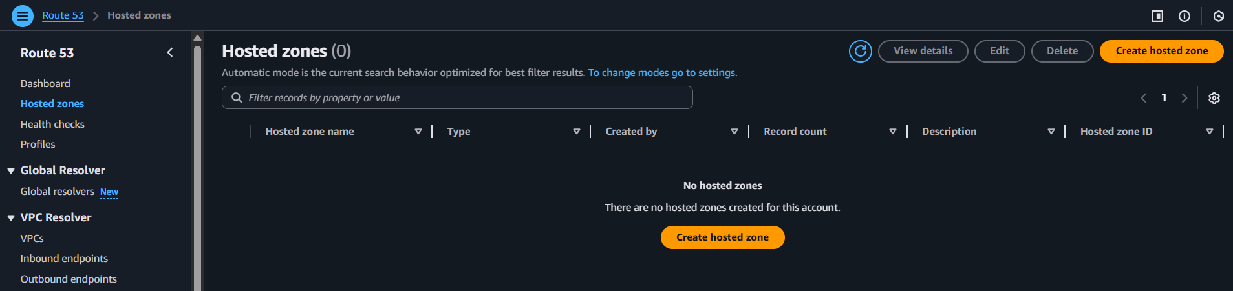

Provide name as DOMAIN NAME and continue
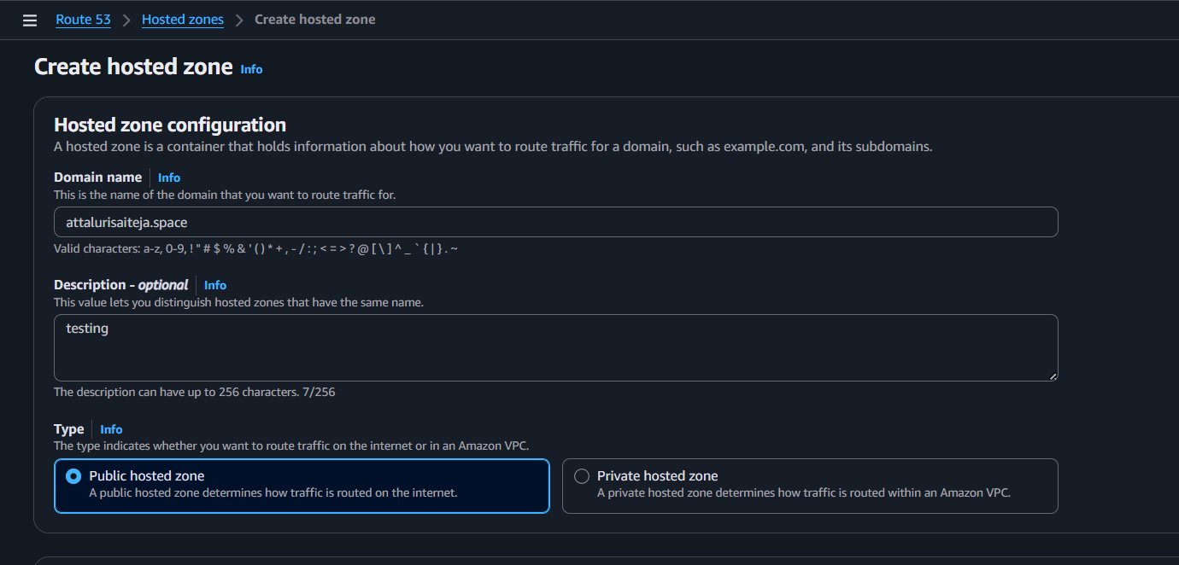
Successfully Hosted a Zone now click on create record
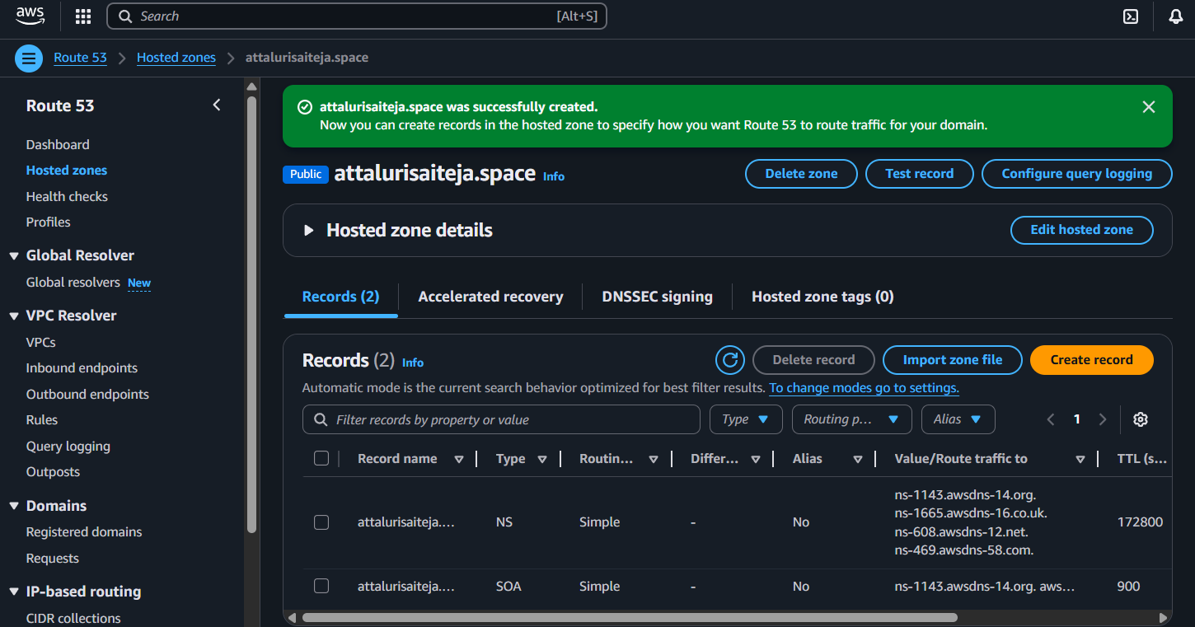

Copy the name servers from ROUTE 53 and Paste in GOdaddy nameservers
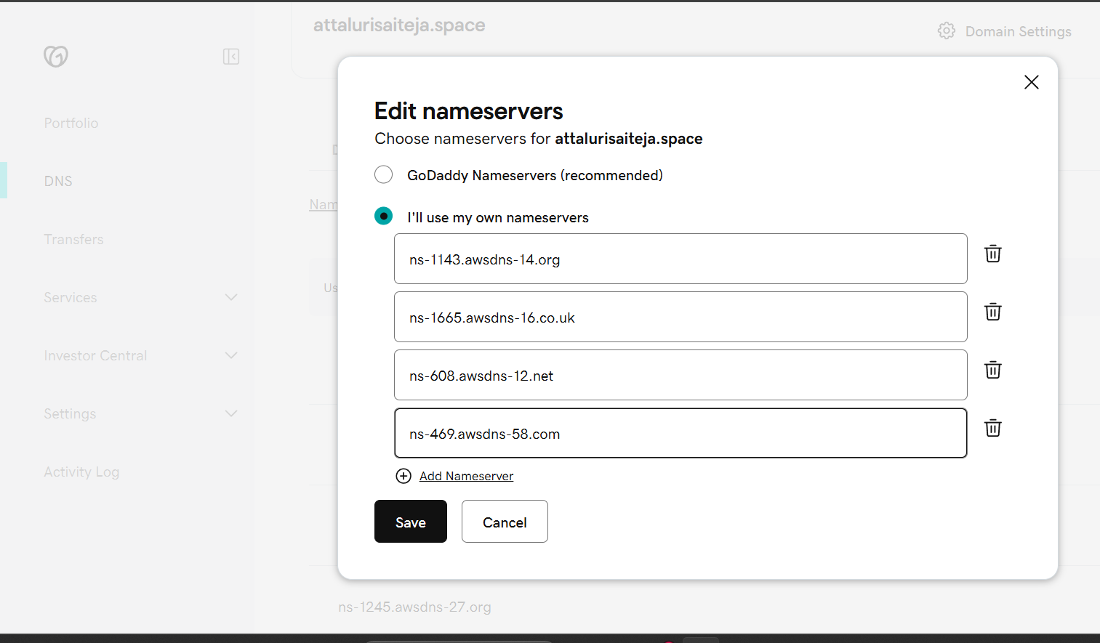
Step 3: Navigate to ACM And create a certificate for your Domain
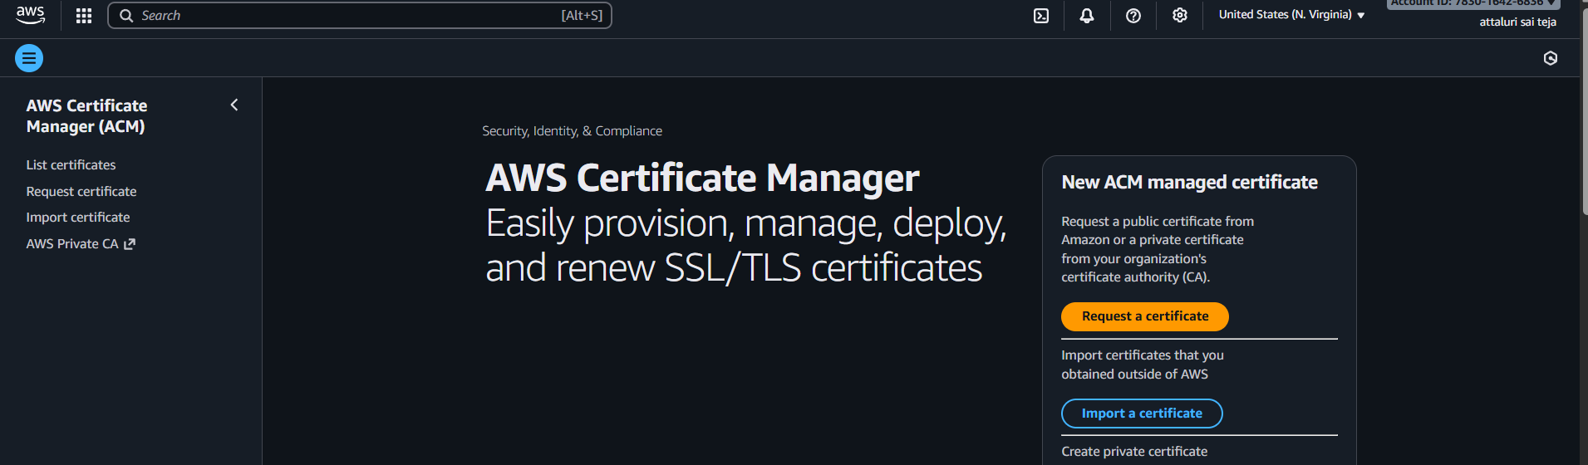
Select public certificate
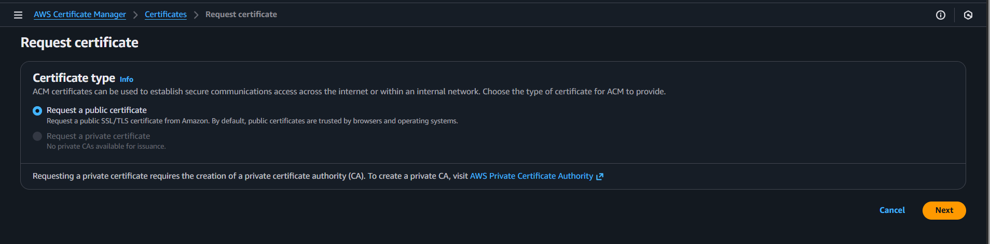

Name should be matched with your domain name
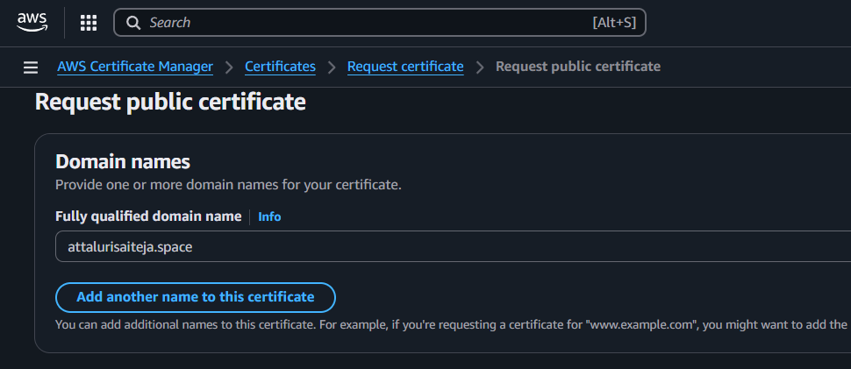
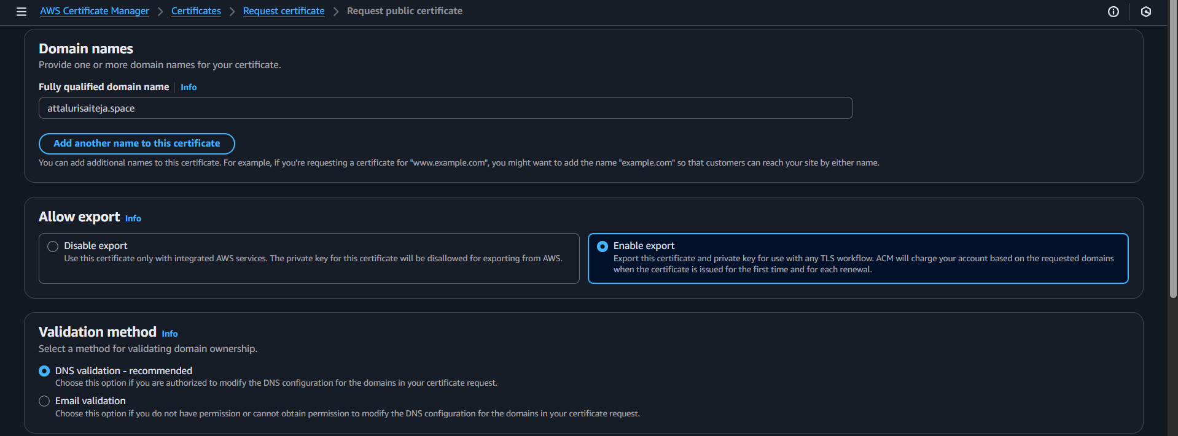
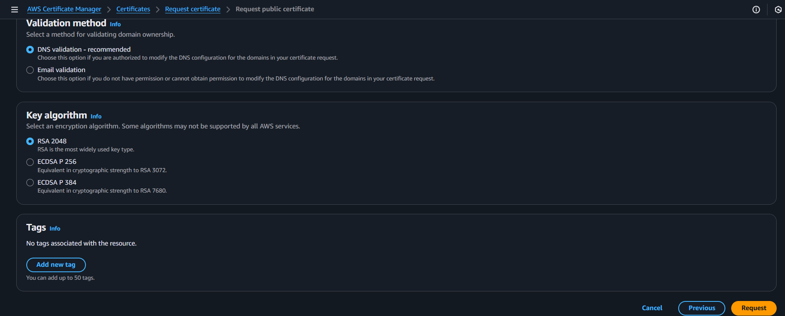
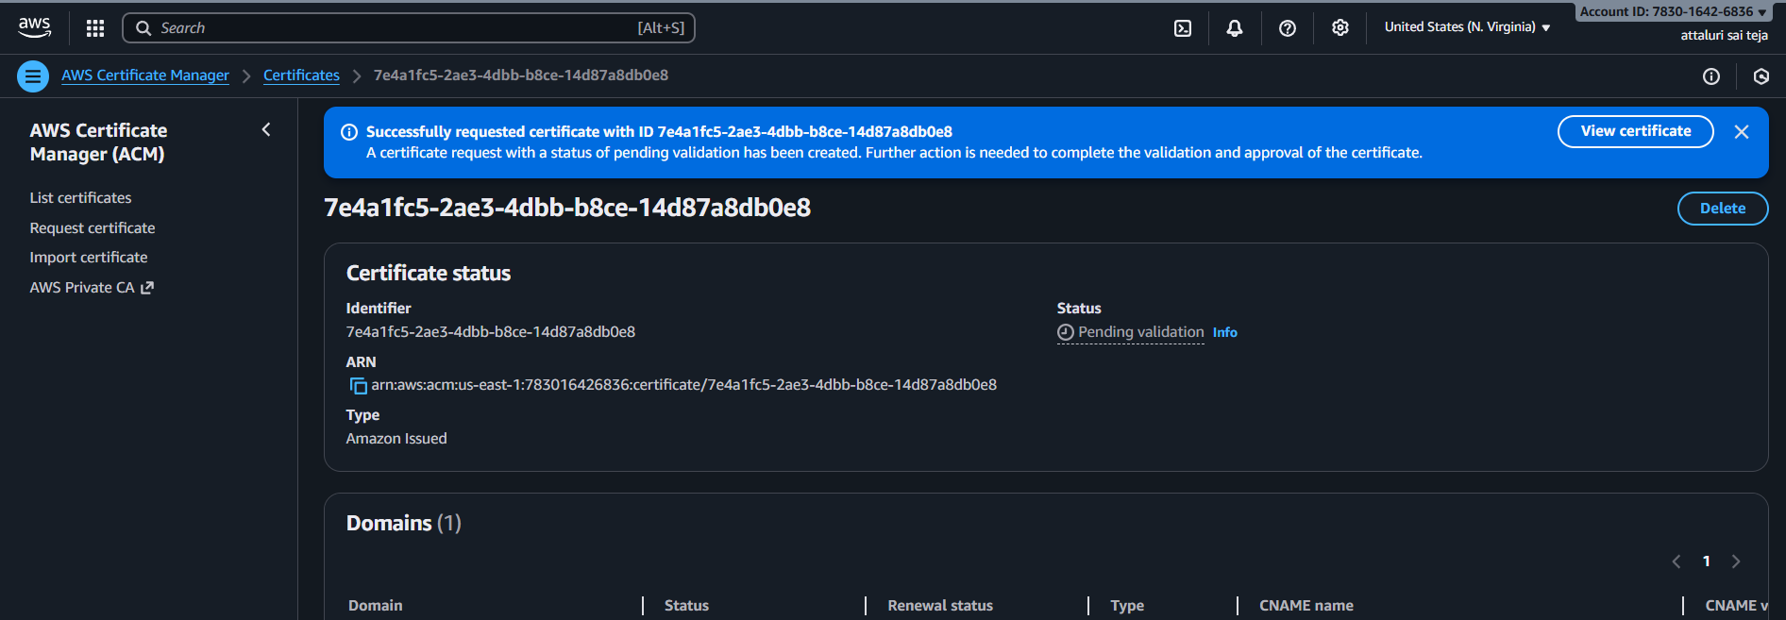
Certificate status was pending it takes some time to issue
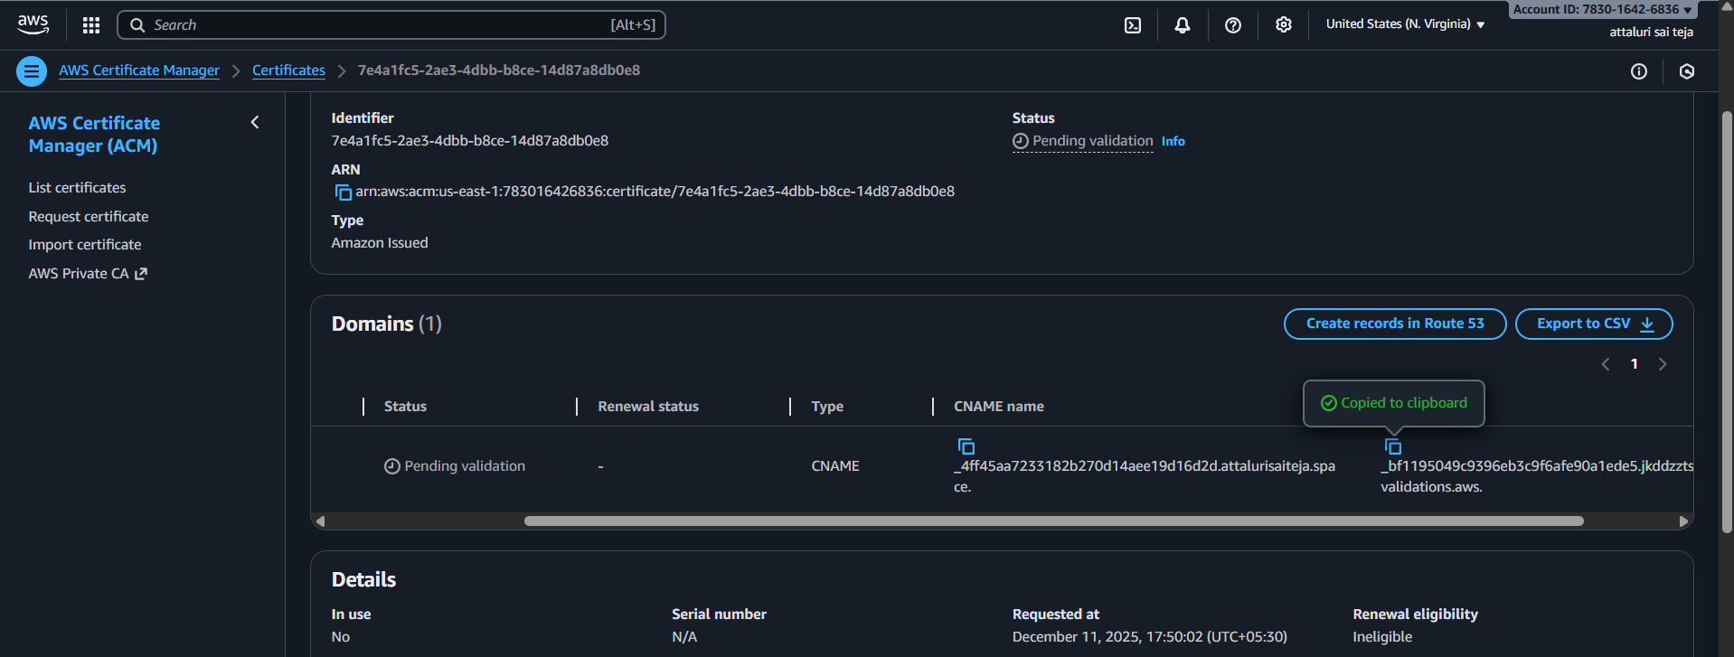
Step 4: Click on Create record in Route 53 and paste record name value which copied from ACM certificate manager
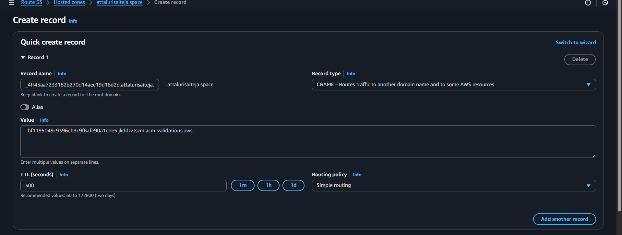
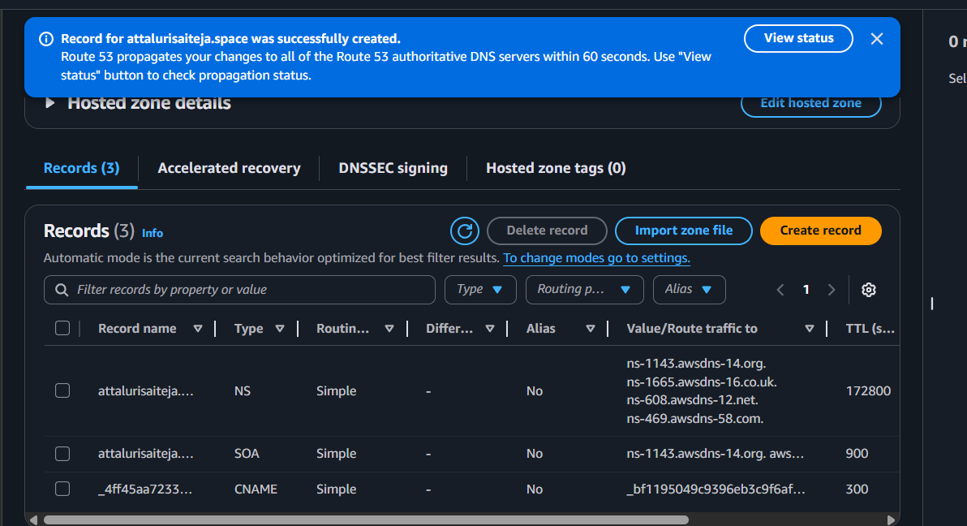
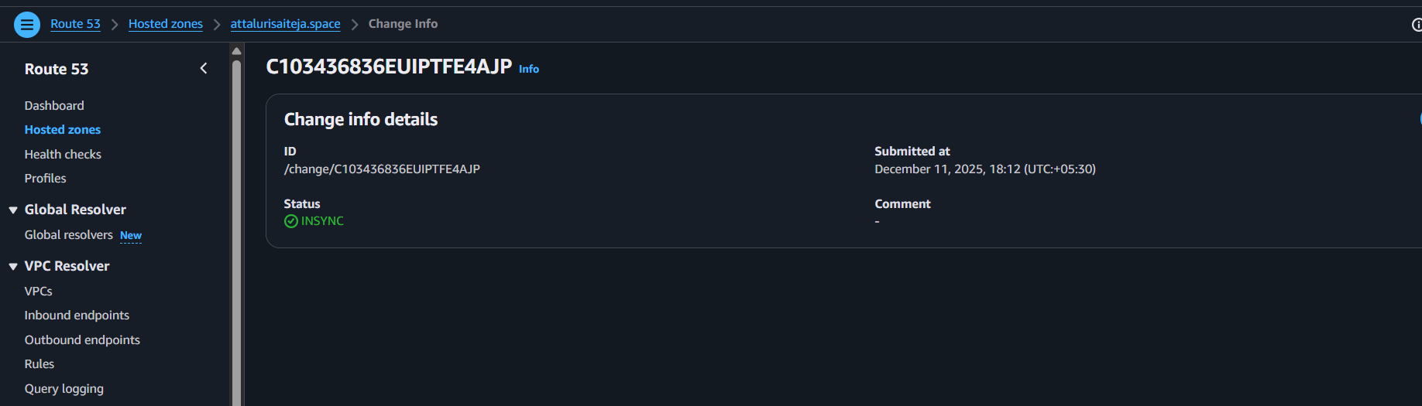
Step 5: Then Create another record for record A and Enable Alias and select the appropriate options and select load balancer and continue
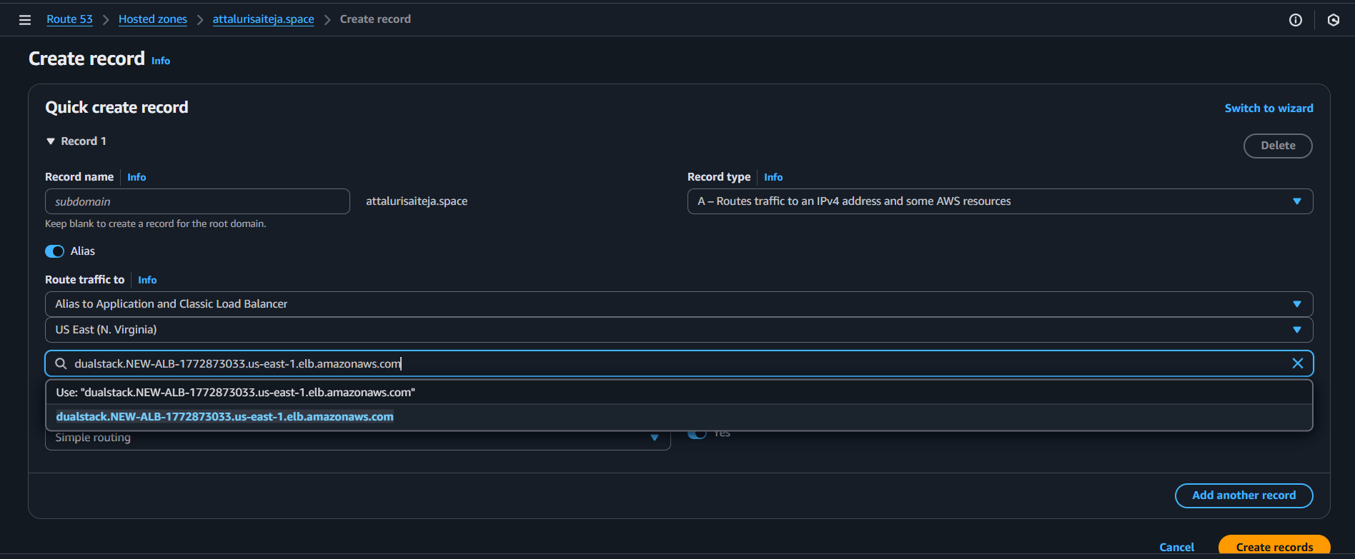
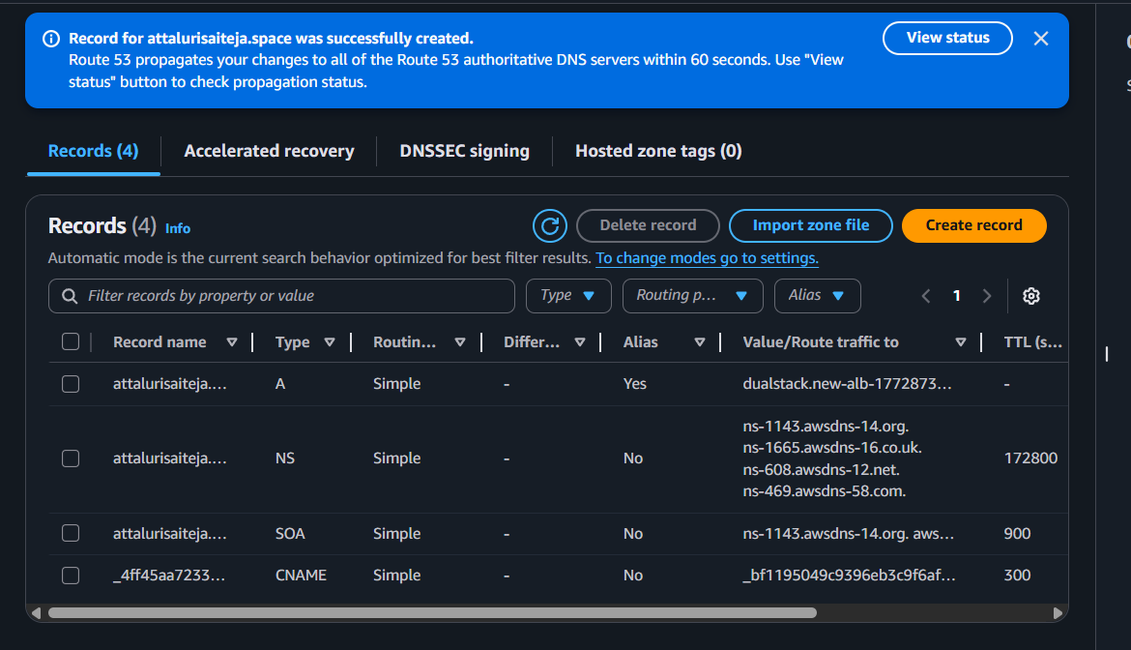
AFTER THE PROCESS YOUR CERTIFICATE WILL BE ISSUED
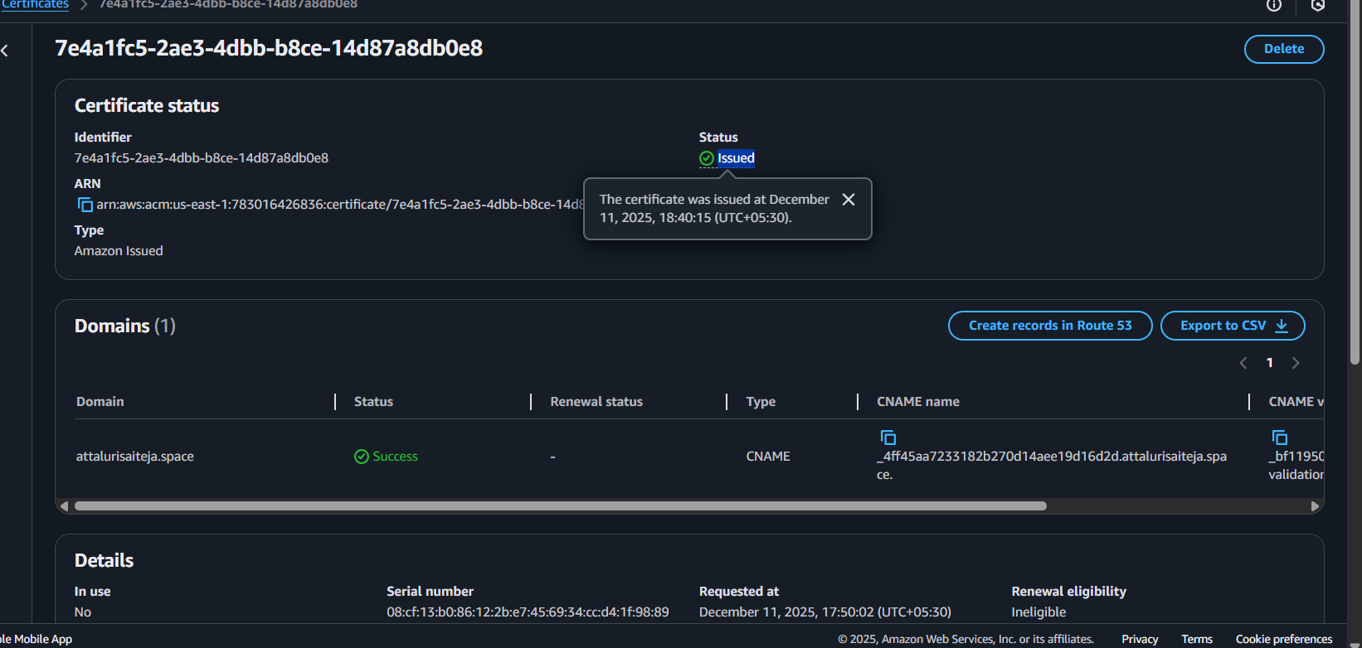

Step6: In the Load balancers tab Click on Listeners tab and add HTTPS 443 port number and continue
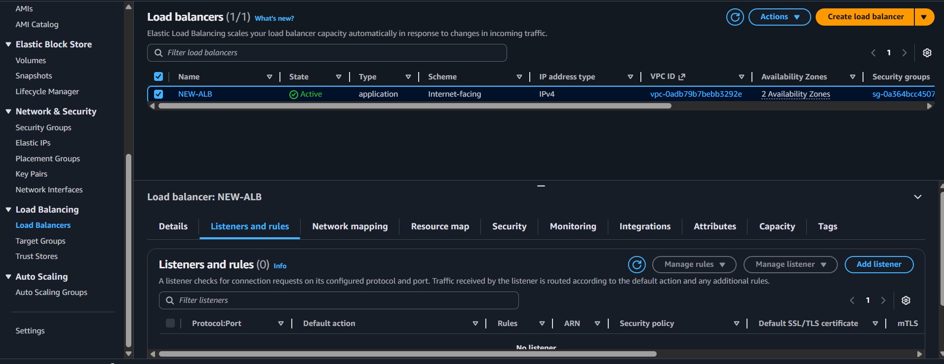
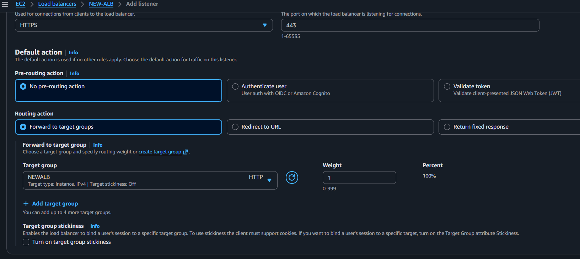
Step 7: Select the ACM certificate and continue
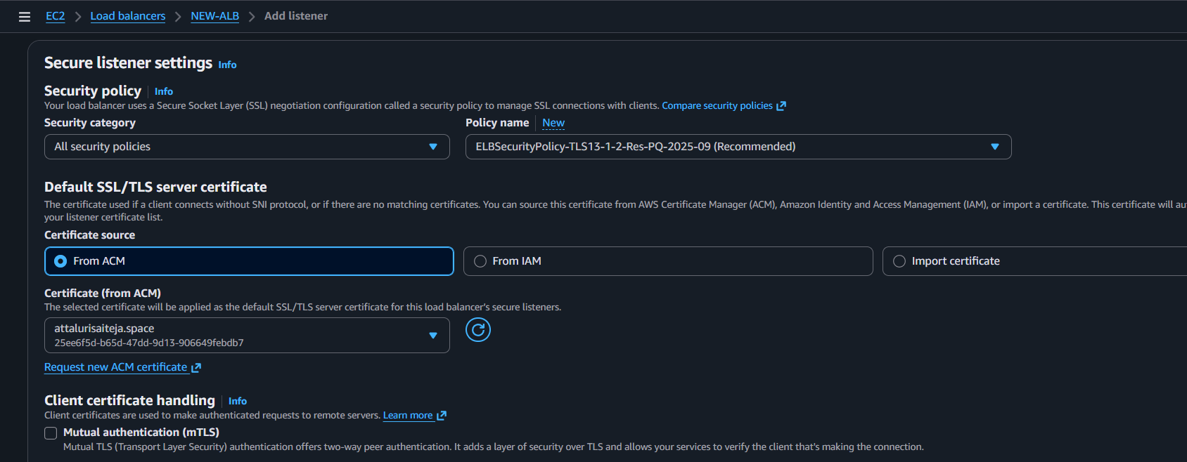
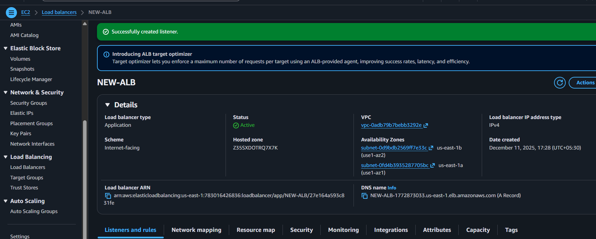
And verified using my domain and it worked
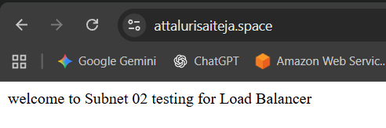
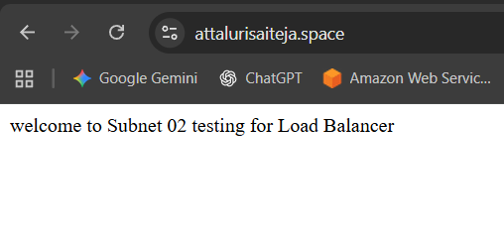

Title:
- Push the application load balancer logs to S3.
Objective:
To enable and configure Application Load Balancer (ALB) access logs so that all traffic logs are automatically delivered to an S3 bucket.
This allows centralized storage, analysis, auditing, and long-term retention of ALB request data.
Prerequisites:
- Existing ALB – The load balancer must already be created.
- S3 bucket in same region – Dedicated bucket to store ALB logs.
- Correct S3 bucket policy – Allow ELB service to write logs.
- IAM permissions – User/role needs ELB + S3 modify permissions.
- Enable ALB access logging – Set bucket name and optional prefix.

Step by Step Implementation
Step 1: Create a bucket and get inside of the bucket
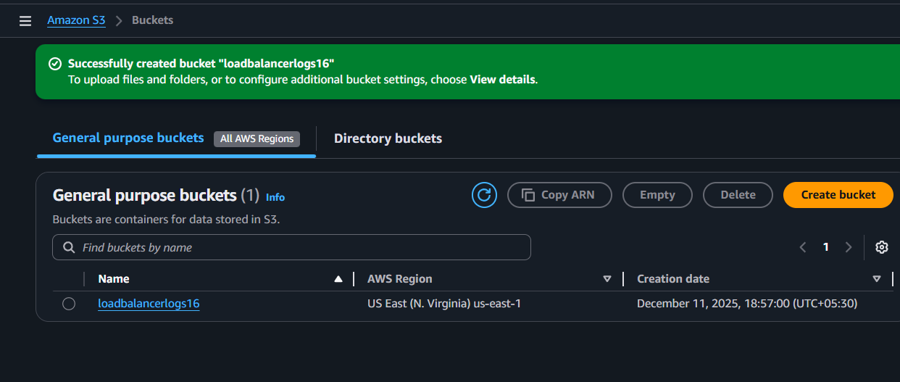
Provide a JSON Policy in bucket policy to the logs getb stored from load balancer to S3
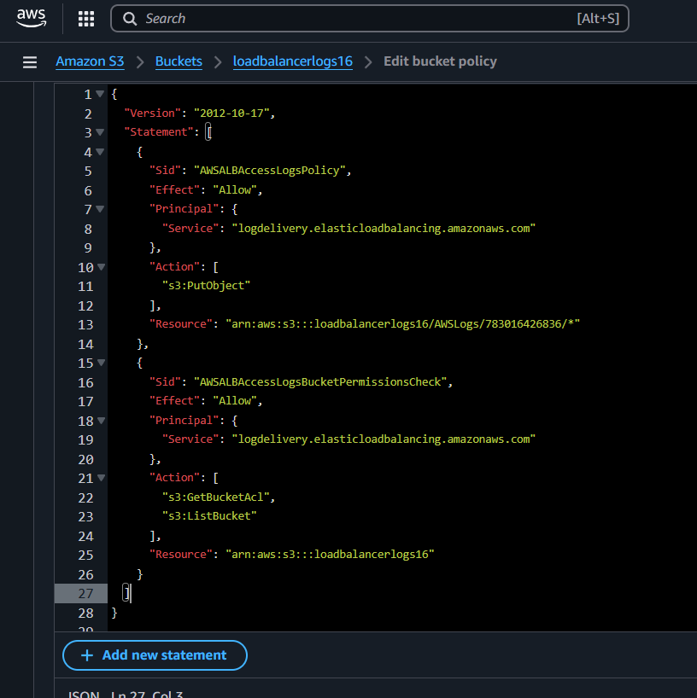
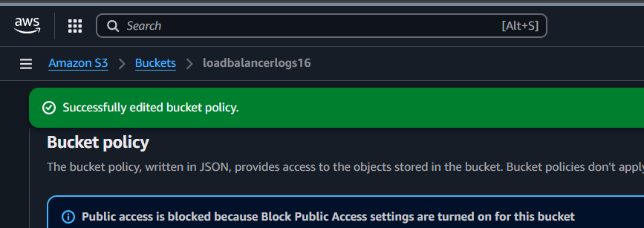

Navigate to LOAD BALANCER and Click on attributes and select EDIT and Enable ACCESS LOGS Option
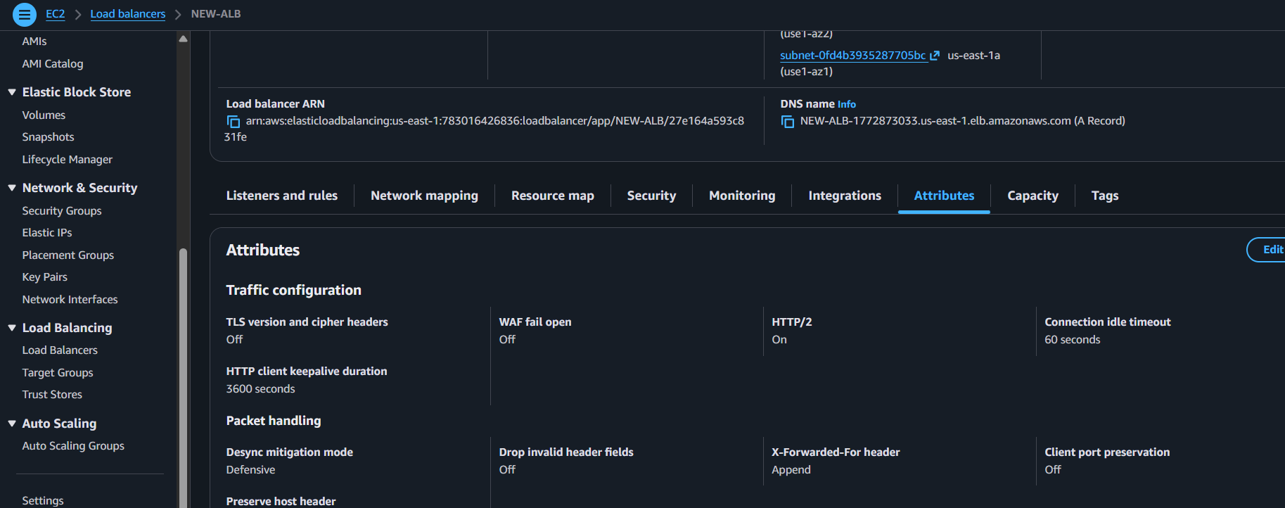
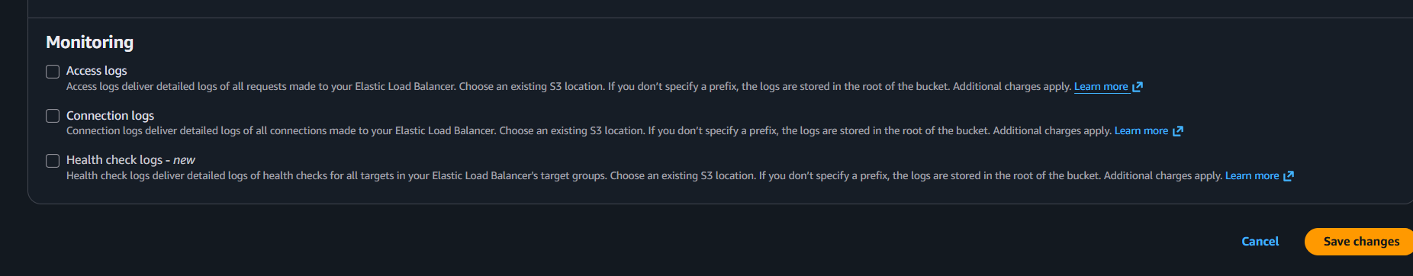
Select the Bucket And Continue
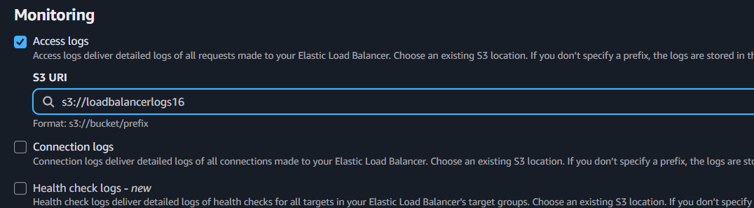
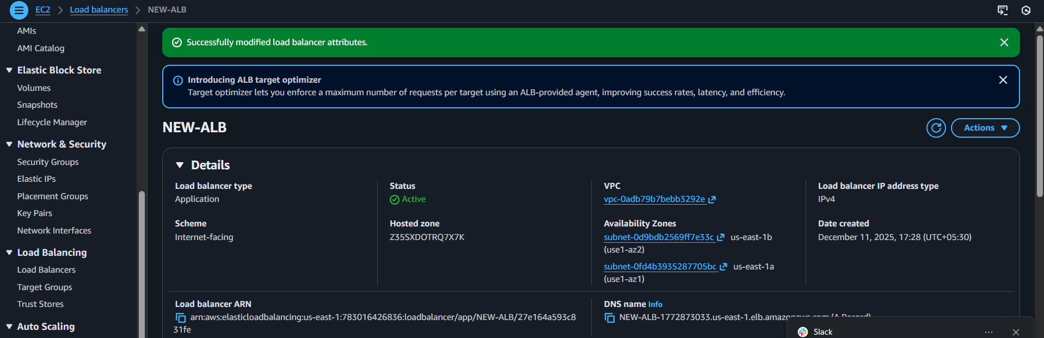

Navigate to S3 and wait for some time the Bucket gets logs of Load balancer
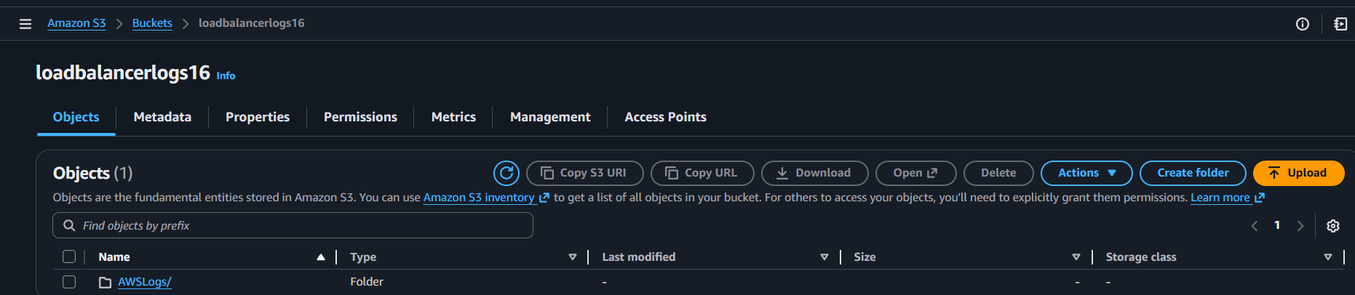
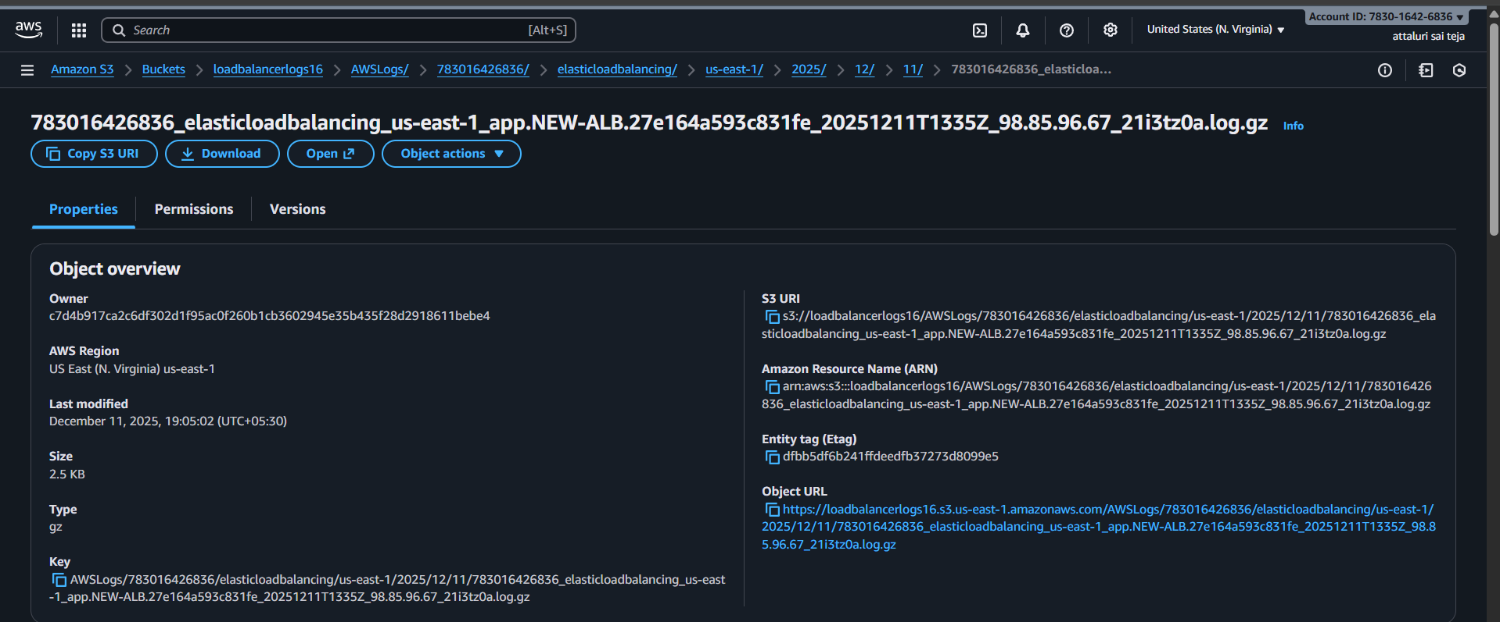
Logs were Stored Successfully
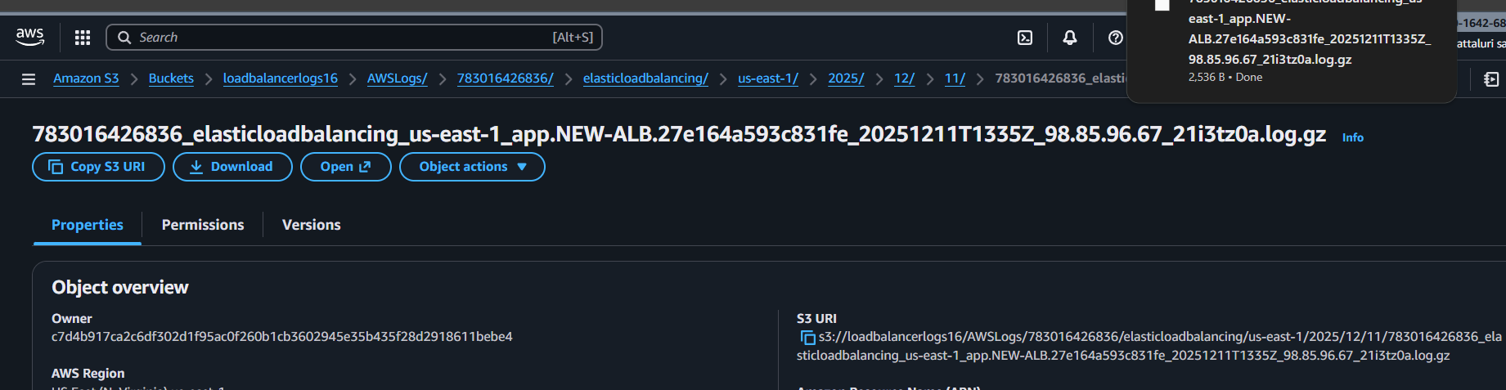
Conclusion
By configuring ALB access logs to be stored in Amazon S3, you gain full visibility into load balancer traffic, including client IPs, request paths, response codes, and latencies.
It helps improve security, operational monitoring, troubleshooting, and compliance, while keeping costs low through S3’s scalable storage.

